Annex N: Tourism in the Project Landscape, and potential Project interventions

‘The project titled Managing together: Integrating community-centred, ecosystem-based approaches into forestry, agriculture and tourism sectors is funded by the sixth programme cycle of the Global Environment Facility (GEF). The Ministry of Mahaweli Development and Environment (MoMDE) is the national focal point for the GEF, The United Nations Development Programme (UNDP) is the GEF agency and the International Union for Conservation of Nature (IUCN) is the agency leading the project development. The project is currently at its preparation stage and aims to take an integrated, community-centred and ecosystem-based approach to mainstream biodiversity-sensitive best practices into the development of forestry, agriculture and tourism sectors. Component 3 expects biodiversity-friendly tourism practices and infrastructure in place within this project landscape.

The project landscape was identified along the Malwathu Oya (Aruvi Aru) watershed and the adjacent environs including contiguous forest patches extending beyond the watershed boundary. Hence the project landscape broadly encompasses the adjacent watersheds of Modaragam Aru, Kal Aru and Nay Aru in addition to the Malwathu Oya. Further the Seascape adjacent to the Malwathu Oya estuary is also considered as a part of this project. Three sites within this landscape and the seascape have been identified for project activities’ (IUCN, 2018).

Given Mannar Island’s increasing popularity as an avi-tourism site, it is included in descriptions, analyses and proposals for sustainable tourism activities under this project although it is outside the Project Landscape and the three selected Trial Landscapes.

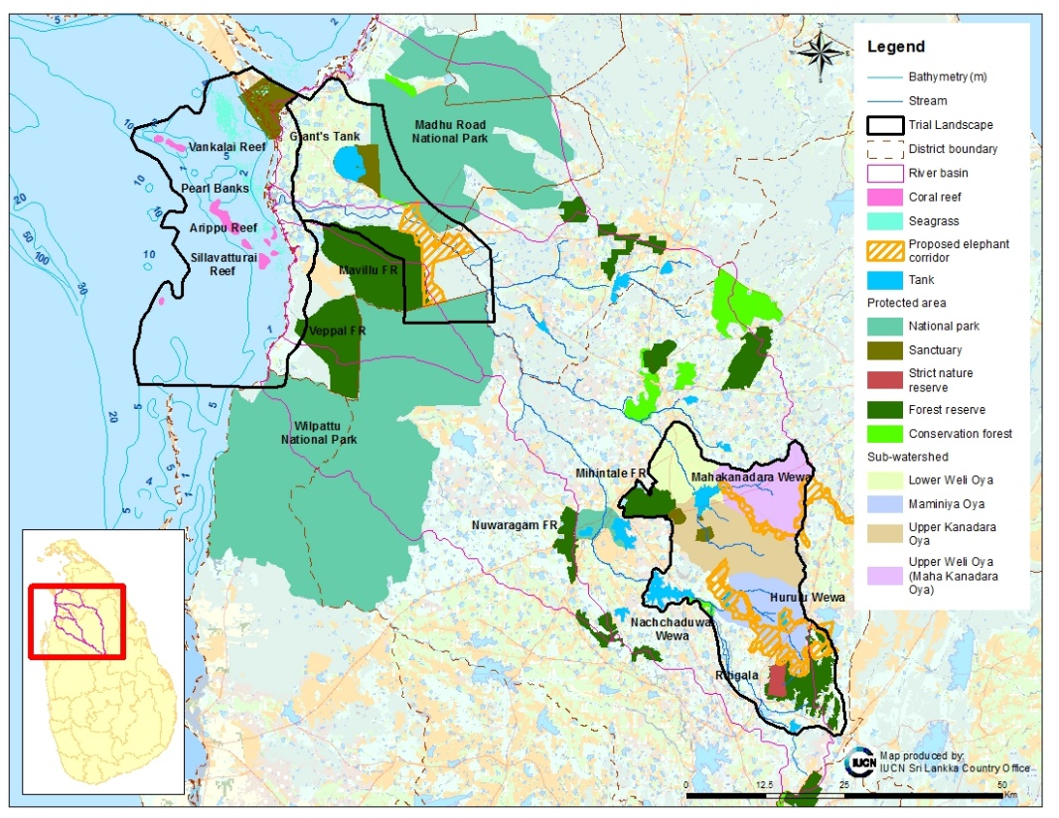

Figure 1: Proposed project landscape and the three Trial Landscapes
(Source: IUCN, 2018)

Existing, emerging and possible tourism sites within the project landscape

Figure 2 details the nature and culture-based tourism attractions within the proposed Trial Landscapes of the project and Table 1 provides brief descriptions of these Trial Landscapes; their value for tourism; the number of facilities registered with the SLTDA; a rough estimate of tourist accommodation shown on Booking.com, AirBnB and Agoda; their distance to the nearest tourism hub, the distance from Colombo and the type of road.
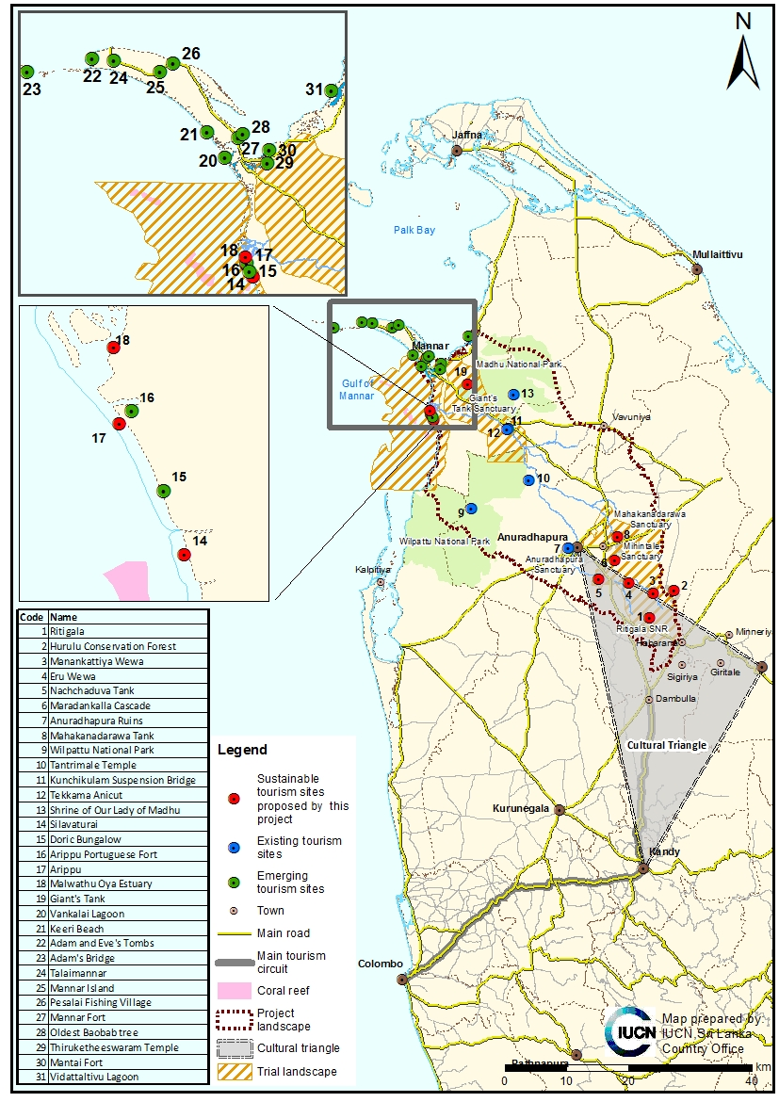

Figure 2: Existing, emerging and proposed tourism sites in the proposed project landscape

Table 1. Nature, culture and adventure-based tourism attractions in the proposed Trial Landscapes
(*denotes locations proposed by the field team after preliminary discussions during the reconnaissance visit and subsequent field visits)
1 | Ritigala*
- Ritigala mountain is the highest isolated mountain of the dry zone of Sri Lanka, rising 766 m.
- During the southwest monsoon, when the dry lowlands suffer a dearth of rain, Ritigala is shrouded in mist. The condensation from this mist keeps the soils moist, and as a result Ritigala is the wettest place in the dry zone.
- The isolation of the range of mountain and these peculiar climatic conditions give rise to a unique assemblage of plants that, in turn, house a variety of animals.
- At the apex of the peaks are Dry Zone Montane Forests not found elsewhere in the dry zone and species found in the sub-montane and montane forests of the wet zone are found here.
- These forests change gradually into Intermediate Transition Forests at altitudes between 250-450 m above sea level. Below these are Monsoon Forests, characteristic of the dry lowlands.
- On the eastern side of the mountain lies a monastic complex of some 150 stone carvings, about 70 rock caves, and about 140 archaeological building dating back to the 9th century BC. History chronicles that several Sri Lankan Kings took refuge in this mountain clothed in dense forest. Ritigala, therefore, not only has immense biological significance but is also an important and popular archaeological site.
- According to the epic legend Ramayanaya, Rama and Ravana battled for Sita, Rama’s consort who has been kidnapped by Ravana. During this battle, Lakshmana, Rama’s younger brother, was mortally wounded. Rama sent Hanuman (a warrior from a race of ape-like humans) to find Sanjivani, a life-restoring herb from the Himalayas. When Hanuman reached the Himalayas, he realised that he has forgotten the name of the herb. He grabbed a chunk of the mountain and brought it back to Rama, who chose the correct herb. Hanuman tossed the rest of the mountain, which broke into two pieces - one of which is Rummassala, in the southwest of the island, and the other Ritigala, in the heart of the dry lowlands.
- Close by to Ritigala (in Habarana) there is a lot of elephant watching.
Value | Protected area/  species? | Type of tourism |  |  |  |  |  | Distance to closest  established tourism hub | Distance to  closest emerging tourism hub |  | Accommodation | Access from Colombo  International airport | Type of road
Value | Protected area/  species? | Nature-based sustainable tourism |  |  | Culture-based sustainable tourism | Adventure-based sustainable tourism | Agro-based sustainable tourism
- High biodiversity value;  - High cultural value. | Yes, it is provided the highest level of protection as SNR under the jurisdiction of the DWC | - Possible, but only if SNR is downgraded.  - Setting up elephant safaris was recommended at the reconnaissance visit by the stakeholders. This will need intensive training, establishment of codes of conduct for jeep drivers and best-practice guidelines for management.  Communities in Dambulla and Habarana are shifting increasingly towards tourism related livelihoods and avoiding illegal chena cultivation and encroachments into protected areas. |  |  | Yes, outside the SNR, already occurring, with 3,380 foreign and 49,432 local visitors in 2016. | — | — | 19.8 km from  Habarana | Not  Applicable |  | In Habarana: One hundred and twenty-six properties listed on Booking.com; 240 on Airbn’b; and 11 registered with the SLTDA. | 169 km  ~4 hr drive | Main access road, on main tourism circuit.
2 | Hurulu Forest Reserve*
- This area was designated as a biosphere reserve in 1977 and extends over 25,500 ha of tropical dry evergreen.
- This area provides important habitat for the Asian elephant (Elephas maximus).
- The reservoir which this forest reserve surrounds is picturesque (UNESCO, 2002).

Value | Protected area/  species? | Type of tourism |  |  |  |  |  | Distance to closest  established tourism hub | Distance to  closest emerging tourism hub |  | Accommodation | Access from Colombo International airport | Type of road
Value | Protected area/  species? | Nature-based sustainable tourism |  |  | Culture-based sustainable tourism | Adventure-based sustainable tourism | Agro-based sustainable tourism
- High biodiversity value | Yes, biosphere reserve, a small section of this has an eco-park where elephant safaris are already conducted. | Yes, for elephant safaris. This will need intensive training, establishment of codes of conduct for jeep drivers and best-practice guidelines for management. |  |  |  |  |  | 6.8 km from Habarana | Not applicable |  | In Habarana: 126 properties listed on Booking.com; 240 on Airbn’b; and 11 registered with the SLTDA | 156 km, approx. 3.75 hr | Main access road, on main tourism circuit.
3 | Manankattiya Sanctuary*
Manankattiya tank is thought to have been built by King Vasabha in 3 AD. The tank is fed by streams flowing from Ritigala (IWMI, 1997).
Under the Upper Elahera Canal Project, currently under way under the Mahaweli Development Authority, it is expected that water from the newly built Moragahakande Reservoir will be sent to this tank.
Value | Protected area/  species? |  | Type of tourism |  |  |  |  | Distance to closest  established tourism hub | Distance to  closest emerging tourism hub |  | Accommodation | Access from Colombo International airport | Type of road
Value |  |  | - Nature-based sustainable tourism |  | Culture-based sustainable tourism | Adventure-based sustainable tourism | Agro-based sustainable tourism
- High biodiversity value | Yes, a sanctuary under the DWC |  | - Yes, possible for elephant safaris. Setting up elephant safaris, shops, dining though community-based livelihoods projects could be established in Wannamkulama village and the stretch towards Nachchadoova wewa.  - This will need intensive training, establishment of codes of conduct for jeep drivers and best-practice guidelines for management. |  |  |  |  | 32.5 km from  Habarana. | Not applicable |  | In Habarana: 126 properties listed on Booking.com; 240 on Airbn’b; and 11 registered with the SLTDA | 175 km. approx.  4 hr | Main access road, along main tourism circuit.
4 | Eru Wewa*
Both Eru Wewa and Manankattiya Wewa has the potential to develop elephant viewing facilities, as these grass in drawdown area of these tanks are being populated by at least 100-150 elephants during each afternoon of the dry season. These tanks are two important stepping stones along the elephant corridor proposed to be established by the Upper Elahera Canal Project, while there is a possibility of declaring these tow tanks and their catchment forests as wildlife sanctuaries. The DWC officers claim that the area is frequented by a heard of about 350 elephants including about 25 tuskers. They specifically added that these include some of the most majestic tuskers in the island.
Value | Protected area/  species? |  | Type of tourism |  |  |  |  | Distance to closest  established tourism hub | Distance to  closest emerging tourism hub | Accommodation |  | Access from  Colombo  International airport | Type of road
Value |  |  | Nature-based sustainable tourism |  | Culture-based sustainable tourism | Adventure-based sustainable tourism | Agro-based sustainable tourism
- High biodiversity value | Proposed as a sanctuary under the UECP canal project |  | - Yes, possible for elephant safaris and for bird watching (water birds)  - Setting up elephant safaris, shops, dining though community-based livelihoods projects could be established in Wannamkulama village and the stretch towards Nachchadoova wewa.  - This will need intensive training, establishment of codes of conduct for jeep drivers and best-practice guidelines for management. |  |  |  |  | 27.8 km from Anuradhapura | Not applicable | In Anuradhapura: 345 units advertised in Booking.com; 300+ on Airbn’b and 38 registered with the SLTDA. |  | 178 km, 4.25 hr | Main access road, along tourism circuit.
5 | Nachchaduwa Tank*
This tank is believed to be one of the sixteen large reservoirs built by King Mahasena (276-303).
Value | Protected area/  species? |  | Type of tourism |  |  |  |  | Distance to closest  established tourism hub | Distance to  closest emerging tourism hub | Accommodation |  | Access from  Colombo  International airport | Type of road
Value |  |  | Nature-based sustainable tourism | Culture-based sustainable tourism |  | Adventure-based sustainable tourism | Agro-based sustainable tourism
High biodiversity value | Proposed as a sanctuary under the UECP canal project |  | Yes, possible for elephant safaris.  As above |  |  |  |  | 25.9 km from Anuradhapura | Not applicable | In Anuradhapura: 345 units advertised in Booking.com; 300+ on Air bn’b and 38 registered with the SLTDA. |  | 178 km,  ~ 4 hr | Main access road, along tourism circuit.
6 | Maradankalla Cascade*
- Maradankalla is a reservoir built, during the Anuradhapura kingdom era, by damming the Kanadara Oya, main tributary of the Malwathu Oya river.
- It is part of a cascade situated just next to existing tourist attractions, Mihintale and Kalu-diya Pokuna.
The cascade borders Mihintale sanctuary and links Manankulama wewa, Maradankalla wewa and many other small village tanks
Value | Protected area/  species? |  | Type of tourism |  |  |  |  | Distance to closest  established tourism hub | Distance to  closest emerging tourism hub | Accommodation |  | Access from  Colombo  International airport | Type of road
Value |  |  | Nature-based sustainable tourism | Culture-based sustainable tourism |  | Adventure-based sustainable tourism | Agro-based sustainable tourism
High cultural value |  |  |  | Yes.  Establishing agro-ecotourism project with a model traditional village with homestay facilities.  This will need intensive training, establishment of codes of conduct for hoestay owners and best-practice guidelines for management. |  |  |  | 22.6 km to Anuradhapura |  | In Anuradhapura: 345 units advertised in Booking.com; 300+ on Air bn’b and 38 registered with the SLTDA. |  | 187 km, ~ 4.25 hr | Main access road, along tourism circuit.
7 | Anuradhapura ruins
- This was a village settlement in the second half of the 6th century BC. It is said that King Pandukabhaya made it the national capital in 380 BC. It was also the third capital of the Rajarata kingdom from 4 BC to 11 AD (Seniviratna, 1997).
- Anuradhapura contains eight sacred sites where the Lord Buddha visited in Sri Lanka. These are Sri Maha Bodhiya. Ruwanwelisaya Thuparamaya, Lovamahapaya Abhayagiri Dagaba, Jetavanarama, Mirisaveti Stupa and Lankarama
Value | Protected area/  species? |  | Type of tourism |  |  |  |  | Distance to closest  established tourism hub | Distance to  closest emerging tourism hub | Accommodation |  | Access from  Colombo  International airport | Type of road
Value |  |  | Nature-based sustainable tourism | Culture-based sustainable tourism |  | Adventure-based sustainable tourism | Agro-based sustainable tourism
High cultural value | Yes, as a sanctuary under the jurisdiction of the DWC; also a World Heritage Site |  |  | Yes, part of the cultural triangle, which is a major tourist attraction, 77,703 foreign and 54,638 local tourists in 2016. Well-established location and tour route. |  |  |  | Is a main tourism hub | Not applicable | Three hundred and forty-five units advertised in Booking.com; 300+ on Air bn’b and 38 registered with the SLTDA.  See also Table 2 |  | 169-172 km, approx. 3.5 hr | Main access road, on main tourism circuit.
8 | Mahakanadarawa Reservoir*
Mahakandarawa Reservoir, also called KanaWapi in ancient literature is one of the large tanks in Anuradhapura District, though to be built by King Mahasen. The embarkment of the tank itself is 2.8 km long while it covers an area of 34,000 acres when full. While being very important for the irrigation based agricultural livelihoods of the area the tank and its catchment area provides a vast array of habitats for biodiversity including the provisions for a considerable populations of elephants migrating through the catchment forests.
Value | Protected area/  species? |  | Type of tourism |  |  |  |  | Distance to closest  established tourism hub | Distance to  closest emerging tourism hub | Accommodation |  | Access from  Colombo  International airport | Type of road
Value |  |  | Nature-based sustainable tourism | Culture-based sustainable tourism |  | Adventure-based sustainable tourism | Agro-based sustainable tourism
High biodiversity value | Yes, a sanctuary under the DWC |  | Yes, possible for elephant safaris. This will need intensive training, establishment of codes of conduct for jeep drivers and best-practice guidelines for management. |  |  |  |  | 22.4 km from ANuradhapura | Not applicable | Accommodation as shown in 7 |  | 193 km, 4.25 hr | Main access road, along tourism circuit
9 | Part of Wilpattu National Park*
- The largest (1,317 s km²) and one of the oldest national parks in Sri Lanka, unique for its villus — shallow depressions in which rain water fills. About 60 villus are found with the park, and provide watering holes for a range of species, including leopard, sloth bear, elephant and barking deer, as well as many water birds, and reptiles such as the mugger crocodile.
- Also within the park is Kudremalai Point, which is believed to be the area at which Prince Vijaya, banished from Orissa, landed in Sri Lanka.
Fossil deposits of fauna and prehistoric human settlements have been found in Kudremalai.
Value | Protected area/  species? |  | Type of tourism |  |  |  |  | Distance to closest  established tourism hub | Distance to  closest emerging tourism hub | Accommodation |  | Access from  Colombo  International airport | Type of road
Value |  |  | Nature-based sustainable tourism | Culture-based sustainable tourism |  | Adventure-based sustainable tourism | Agro-based sustainable tourism
- High wildlife value, relatively easy sightings of charismatic species  - Historic value of Kudremalai. | Yes, as a national park under the jurisdiction of the DWC |  | Yes, well-established tour location with increasing numbers post war, from 2,322 foreign and 22,972 local tourists in 2011, to 19,505 foreign and 49,068 local tourists in 2016.  If an entrance is established at the northern of the Park, with demarcation of boundaries and tourism tracks, this could be included into a new tour route.  This will need intensive training, establishment of codes of conduct for jeep drivers and best-practice guidelines for management. | Many of the tourists visiting the park also visit Kudremalai point. |  |  |  | 38.6 km from Anuradhapura | Not applicable | Six properties on Booking.com; 16 on AirBn’B. However, 209 properties listed from about 12-25 miles away (from Kalpitiya, Anuradhapura and Maragahawewa |  | 137 km about 3hr | Main road
10 | Tantrimale/Thanthrimale Temple*
- When the sacred Bo sapling was brought to Sri Lanka, it was kept for one night at Tantrimale.
- King Devanampiyatissa also chose to plant one Bodhi at Tanthirimale out of the first eight shoots to spring off from Jaya Sri Maha Bodhi in Anuradhapura.
- The area is renowned for its many caves, inscriptions, rock carvings, ruins of monastic residences, meditation chambers, a library and the Sacred Bo tree
Built on a rock, Tantrimale offers a specular view of the area at the summit
Value | Protected area/  species? |  | Type of tourism |  |  |  |  | Distance to closest  established tourism hub | Distance to  closest emerging tourism hub | Accommodation |  | Access from  Colombo  International airport | Type of road
Value |  |  | Nature-based sustainable tourism | Culture-based sustainable tourism |  | Adventure-based sustainable tourism | Agro-based sustainable tourism
High cultural value |  |  |  | Ensuring sustainable practices, and control on carrying capacity of visitors.  Yes, already a very popular site. Only further marketing needed. Can be easily included to a tour to Giant’s Tank or . Mannar. |  |  |  | 45 km from Anuradhapura | 78. 7 km from Mannar town  En route to Mannar. Can be easily included to a tour to Mannar. | Accommodation as shown in 7 for Anuradhapura and 25 for Mannar |  | 205 km ~3.75 hr | Main road
11 | Kunchikulam Hanging Bridge
- This is an old suspension bridge across the Malwathu Oya in the area of Kunchikulam. The bridge is over 100 m.
- A new concrete bridge has been built across the river now.
Value | Protected area/  species? |  | Type of tourism |  |  |  |  | Distance to closest  established tourism hub | Distance to  closest emerging tourism hub | Accommodation |  | Access from  Colombo  International airport | Type of road
Value |  |  | Nature-based sustainable tourism | Culture-based sustainable tourism |  | Adventure-based sustainable tourism | Agro-based sustainable tourism
For adventure-based tourism |  |  |  |  |  | Ensuring sustainable practices, and control on carrying capacity of visitors.  Already a tourism site for locals. |  | 79.3 km from Anuradhapura | 41.9 km from Mannar town  En route to Mannar. Can be easily included to a tour to Mannar. | As shown in 25. |  | 247 kn, ~ 5 hr | Main road.
12 | Tekkama Anicut
This anicut was constructed to fill Giant’s Tank
Value | Protected area/  species? |  | Type of tourism |  |  |  |  | Distance to closest  established tourism hub | Distance to  closest emerging tourism hub | Accommodation |  | Access from  Colombo  International airport | Type of road
Value |  |  | Nature-based sustainable tourism | Culture-based sustainable tourism |  | Adventure-based sustainable tourism | Agro-based sustainable tourism
High aesthetic value |  |  |  | Already a tourism site for locals.  Ensuring sustainable practices, and control on carrying capacity of visitors. |  |  |  | 75.8 km from Anuradhapura | 1.9 km from Mannar town  En route to Mannar. Can be easily included to a tour to Mannar. | As shown in 25. |  | 243 km, ~ 5 hr | Main road.
13 | Shrine of Our Lady of Madhu
- Considered one of the holiest locations on the island for Catholics, this church is about 400 years old. Catholics were persecuted during Dutch colonisation and settled in Mantai and set up this shrine.
- Each year in August, a main annual feast is celebrated in the church and draws pilgrims from many faiths.
Value | Protected area/  species? |  | Type of tourism |  |  |  |  | Distance to closest  established tourism hub | Distance to  closest emerging tourism hub | Accommodation |  | Access from  Colombo  International airport | Type of road
Value |  |  | Nature-based sustainable tourism | Culture-based sustainable tourism |  | Adventure-based sustainable tourism | Agro-based sustainable tourism
High cultural value |  |  |  | Yes, already an extremely popular site for local pilgrims.  Ensuring sustainable practices, and control on carrying capacity of visitors. |  |  |  | 105 km from Anuradhapura | 50 km from Mannartown | As shown in 25. |  | 270 km ~5 hr | Main road.
14 | Silavaturai (and also Arippu) seascapes*
- Excellent fringing coral reefs are found off shore here.
- Proto-historic and historical monuments have also been found in these areas
Value | Protected area/  species? |  | Type of tourism |  |  |  |  | Distance to closest  established tourism hub | Distance to  closest emerging tourism hub | Accommodation |  | Access from  Colombo  International airport | Type of road
Value |  |  | Nature-based sustainable tourism | Culture-based sustainable tourism |  | Adventure-based sustainable tourism | Agro-based sustainable tourism
- High biodiversity value  - High archaelogical value | Special Management Areas under the Coast Conservation and Coastal Resource Management Dept. |  | The area has been identified in the project to have potential for a model marine and coastal habitat conservation programme, with the development of sustainable coral reef and mangrove-based eco-tourism, with diving, kayaking, camping, snorkelling.  This will need intensive training, establishment of codes of conduct for boat drivers and best-practice guidelines for sustainable management |  |  |  |  | 77.4 km from Anuradhapura | 46.6 km from  Mannar Town | As shown in 25. |  | 198 km ~ 5 hr | Main road
15 | Doric bungalow
Constructed by the first British governor of Sri Lanka as a bungalow for officers who managed the pearl fisheries in the region.
Value | Protected area/  species? |  | Type of tourism |  |  |  |  | Distance to closest  established tourism hub | Distance to  closest emerging tourism hub | Accommodation |  | Access from  Colombo  International airport | Type of road
Value |  |  | Nature-based sustainable tourism | Culture-based sustainable tourism |  | Adventure-based sustainable tourism | Agro-based sustainable tourism
High cultural value | Protected as an archaeological monument |  |  | Yes, already visited by local tourists.  Ensuring sustainable practices, and control on carrying capacity of visitors |  |  |  | 113 km from Anuradhapura | 39.3 km to Mannar town | As shown in 25. |  | 198 km ~ 5 hr | Main road
16 | Arippu Portuguese Fort
- Built by the Portuguese in the 17th century, the ruins of this Fort are still visible.
- It was to this fort that Robert Knox escaped from imprisonment by the Kandyan king and was later sent to England
Value | Protected area/  species? |  | Type of tourism |  |  |  |  | Distance to closest  established tourism hub | Distance to  closest emerging tourism hub | Accommodation |  | Access from  Colombo  International airport | Type of road
Value |  |  | Nature-based sustainable tourism | Culture-based sustainable tourism |  | Adventure-based sustainable tourism | Agro-based sustainable tourism
High cultural value | Protected as an archaeological monument |  |  | Yes, already visited by local tourists.  Ensuring sustainable practices, and control on carrying capacity of visitors |  |  |  | 119 km from Anuradhapura | 39.3 km to Mannar town | As shown in 25. |  | 198 km ~ 5 hr | Main road
17 | Arippu*
As above in 14
Value | Protected area/  species? |  | Type of tourism |  |  |  |  | Distance to closest  established tourism hub | Distance to  closest emerging tourism hub | Accommodation |  | Access from  Colombo  International airport | Type of road
Value |  |  | Nature-based sustainable tourism | Culture-based sustainable tourism |  | Adventure-based sustainable tourism | Agro-based sustainable tourism
High biodiversity value |  |  | As above in 13. |  |  |  |  | 119 km from Anuradhapura | 39.3 km to Mannar town | As shown in 25. |  | 198 km ~ 5 hr | Main road
18 | Malwathu Oya (Aruvi Aru) estuary*
The northern side of this estuary has beautiful vistas of dense mangroves, salt marshes and tidal flats, where waters birds congregate.
Value | Protected area/  species? |  | Type of tourism |  |  |  |  | Distance to closest  established tourism hub | Distance to  closest emerging tourism hub | Accommodation |  | Access from  Colombo  International airport | Type of road
Value |  |  | Nature-based sustainable tourism | Culture-based sustainable tourism |  | Adventure-based sustainable tourism | Agro-based sustainable tourism
High biodiversity value |  |  | Kayaking can be promoted in this area for bird watching and for mangroves and salt marshes. |  |  |  |  | Not applicable | Approx. 40 km from Mannar Town | As shown in 25. |  | 198 km ~ 5 hr | Main road
19 | Giant’s tank*
- This is a reservoir built by damming Maltwathu Oya 35 km from its mouth. This tank now has a storage capacity 38,854,678 m³ . The date of construction of this tank is in dispute.
- The water from this tank is fed to 162 smaller tanks downstream and irrigates about 11,000 ha of rice cultivation.
- This is important for fisheries.
- Birds seen in the area include the long-tailed shrike, glossy ibis, black drongo, crab plover, Indian courser, Eurasian wigeon, garganey, knob-billed duck and pygmy goose.
Value | Protected area/  species? |  | Type of tourism |  |  |  |  | Distance to closest  established tourism hub | Distance to  closest emerging tourism hub | Accommodation |  | Access from  Colombo  International airport | Type of road
Value |  |  | Nature-based sustainable tourism | Culture-based sustainable tourism |  | Adventure-based sustainable tourism | Agro-based sustainable tourism
- High value for fisheries  High value for avi-tourism | Yes, as a sanctuary under the jurisdiction of the DWC |  | Yes. This is easily accessible, as it is en route to Mannar. There is also an unused building, previously belonging to the Divisional Secretariat, which can be used as an interpretation centre.  This will need intensive training, establishment of codes of conduct for boat drivers and best-practice guidelines for sustainable management |  |  |  |  | 107 km from Anuradhapura | Approx. 22.6 km from Mannar town | As shown in 25. |  | 262 km and 5.15 hr. | Main road.
20 | Vankalai lagoon
- This is a sanctuary encompassing several small islands between Mannar Island and the mainland (such as Kalliaditivu, Puliyantivu and Pallimunai) and the strips of land on either side of the causeway connecting the island of Mannar to the mainland. The sanctuary extends over 4,800 hectares and is home to some 20,000 migrant birds each year. Vankalai is the last staging point at the end of the migratory season.
- Species such as Indian spot-billed ducks, Eurasian widgeons, avocets, common teals, northern shovellers, pintails, gargeneys, greater flamingos, crab plovers, oystercatchers, red knots, great knots, ruffs, lesser crested terns, great crested tern, Caspian tern, white-winged black tern, little tern, great black-headed gulls, Heuglin’s gulls, brown-headed gulls can be seen here.
Mangroves, tidal flats, seagrass meadows and coral reefs are found in the area.
Value | Protected area/  species? |  | Type of tourism |  |  |  |  | Distance to closest  established tourism hub | Distance to  closest emerging tourism hub | Accommodation |  | Access from  Colombo  International airport | Type of road
Value |  |  | Nature-based sustainable tourism | Culture-based sustainable tourism |  | Adventure-based sustainable tourism | Agro-based sustainable tourism
High value for biodiversity | Yes, a sanctuary under the jurisdiction of the DWC, also a Ramsar site |  | - Yes, ideal for specialist avi-tourism Post-war, the number of local tourists to the area is increasing, mainly for avi-tourism, with the main attraction being flamingos.  - Water-based activities (snorkelling etc) can also be promoted in the seas around Vankalai  - This will need intensive training, establishment of codes of conduct for boat drivers and best-practice guidelines for sustainable management |  |  |  |  | 112 km from Anuradhapura | Approx. 25 km from Mannar Town | As shown in 25. |  | 265 km, 5.75 hr | Mainly main road.
21 | Keeri beach
- On the southwestern part of the island, this beach has recently been provided with government funds for clean-up and beautification.
- Sea swimming is possible here.
Value | Protected area/  species? |  | Type of tourism |  |  |  |  | Distance to closest  established tourism hub | Distance to  closest emerging tourism hub | Accommodation |  | Access from  Colombo  International airport | Type of road
Value |  |  | Nature-based sustainable tourism | Culture-based sustainable tourism |  | Adventure-based sustainable tourism | Agro-based sustainable tourism
Scenic value | Ensuring sustainable practices, and control on carrying capacity of visitors. |  |  |  |  |  |  | 123 km from Anuradhapura | 4.7 k from Mannar Town | As shown in 25. |  | 304 km, ~5 hr | Main, mostly
22 | Adam and Eve’s tombs
This is an Islamic place of worship. There are two cylindrical structures on the sand covered with green cloth, supposed to be the graves of Adam and Eve. Besides the grave in a replica of a boat, which is believed by Muslims to have brought the banished Adam and Eve to Talaimannar in 786 BC.
Value | Protected area/  species? |  | Type of tourism |  |  |  |  | Distance to closest  established tourism hub | Distance to  closest emerging tourism hub | Accommodation |  | Access from  Colombo  International airport | Type of road
Value |  |  | Nature-based sustainable tourism | Culture-based sustainable tourism |  | Adventure-based sustainable tourism | Agro-based sustainable tourism
Historic value |  |  |  | Already visited by locals.  Ensuring sustainable practices, and control on carrying capacity of visitors. |  |  |  | 149 km from Anuradhapura | 31.7 km from Mannar Town | As shown in 25. |  | 310 km | Main, mostly
23 | Adam’s Bridge
- The second island of Adam’s Bridge serves as the only known breeding site for several species of critically endangered birds including the sooty tern, bridled tern, little tern, Saunders’s tern, roseate tern and brown noddy.
- Around Mannar island’s coastal seas are dugongs, marine turtles and Indo-Pacific finless porpoise.
- The Indian name for Adam’s Bridge is Rama Sethu and is a reference to the Indian legend Ramayanaya. The bridge is supposed to have been built for the Indian Prince Rama to cross from India to Sri Lanka to rescue his wife Sita from Ravana, the king of Sri Lanka.The name Adam’s Bridge was given by a British mapmaker and referred to the legend which said that Adam (the first man in Christianity and Islam who was banished from Eden and fell onto Adam’s Peak) crossed from Sri Lanka along this bridge to go back to the Middle East via India.
Value | Protected area/  species? |  | Type of tourism |  |  |  |  | Distance to closest  established tourism hub | Distance to  closest emerging tourism hub | Accommodation |  | Access from  Colombo  International airport | Type of road
Value |  |  | Nature-based sustainable tourism | Culture-based sustainable tourism |  | Adventure-based sustainable tourism | Agro-based sustainable tourism
High biodiversity value | Yes, a national park under the jurisdiction of the DWC |  | - The promotion of nature-based tourism to this nature-based tourism to this national park will have to be effected with stringent controls.  - For example, Sand Island II should not be open for visitation, as this would disturb the breeding birds. These are all ground nesting birds, so there is also the potential that egg predators — such as feral dogs — could be introduced/ as all of these are ground nesting birds.  - Boats tours, with support from local fishermen are currently being managed by the SL navy during the southwest monsoon period. |  |  |  |  | 147 km from Anuradhapura | 31.7 km from Mannar Town | As shown in 25. |  | 310 km | Main, mostly
24 | Talaimannar
- This is the northernmost part of the island, with a disused pier, which, in earlier times, used to transport goods and people, via a ferry service, to India.
- There is also a fish landing site near the pier, with many fishing boats anchored. Some of these boats may now be hired to go to Adam’s Bridge National Park, when the seas are calm.
- The lighthouse, built in 1915, is visible from here.
- The pier also offers birders the sight of hundreds of several species of gull.
- The road to Talaimannar traverses through extensive thickets of Palmyrah woodlands.
- Proto-historic and historical monuments have been found in Talaimannar.
Value | Protected area/  species? |  | Type of tourism |  |  |  |  | Distance to closest  established tourism hub | Distance to  closest emerging tourism hub | Accommodation |  | Access from  Colombo  International airport | Type of road
Value |  |  | Nature-based sustainable tourism | Culture-based sustainable tourism |  | Adventure-based sustainable tourism | Agro-based sustainable tourism
Historic value |  |  |  | Already visited by locals.  Ensuring sustainable practices, and control on carrying capacity of visitors. |  |  |  | 145 km from Anuradhapura | 29.7 km from Mannar Town | As shown in 25. |  | 310 km | Main, mostly
25 | Mannar Island
- One of the first stops in Sri Lanka for migratory birds travelling on the Central Asian Flyway, and a major wintering site, as well as a staging point before they exit Sri Lanka. These migrants include greater flamingos, bar-tailed godwits, common redshanks, various species of ducks, including northern shovellers, garganey and pintails. More than 30% of the birds recorded in Sri Lanka (more than 150 species) have been recorded on the island.
- The island is inhabited by some of the rarest species of birds recorded in Sri Lanka such as the spot-billed duck, black drongo, long-tailed shrike, Eurasian collared-dove and grey francolin.
- Rare winter visitors such as ruddy shelduck and bar-tailed goose have been observed in the recent past.
- Around Mannar island’s coastal seas are dugongs, marine turtles and Indo-Pacific finless porpoise.
- Ecosystems on the island includes tidal flats, salt marshes, extensive palmyrah woodlands, as well as sea grasses, coral reefs and lagoons.
There are many easily accessible locations for bird watching, including the causeway, salterns and several inland ponds such as Kora kulam and coastal tidal flats such as Erukulampiddy.
Value | Protected area/  species? |  | Type of tourism |  |  |  |  | Distance to closest  established tourism hub | Distance to  closest emerging tourism hub | Accommodation |  | Access from  Colombo  International airport | Type of road
Value |  |  | Nature-based sustainable tourism | Culture-based sustainable tourism |  | Adventure-based sustainable tourism | Agro-based sustainable tourism
Very high biodiversity value, | Several threatened birds are found here. |  | Ideal for promoting specialist avi-tourism post-war, the number of local tourists to the island is increasing, mainly for avi-tourism, with the main attraction being flamingos.  Ensuring sustainable practices, and control on carrying capacity of visitors. |  |  |  |  |  |  | SLTDA, (2018) has four listed properties, airbnb.com show nine places to stay  Booking.com shows 13 properties.  However, see also the Table 3. |  | Approximately 304 km, ~5 hr | Main road.
26 | Pesalai fishing village
- This is a fishing village, on the northern coast of the island, where dried fish is made.
- Proto-historic and historical monuments have been found in Pesalai.
Value | Protected area/  species? |  | Type of tourism |  |  |  |  | Distance to closest  established tourism hub | Distance to  closest emerging tourism hub | Accommodation |  | Access from  Colombo  International airport | Type of road
Value |  |  | Nature-based sustainable tourism | Culture-based sustainable tourism |  | Adventure-based sustainable tourism | Agro-based sustainable tourism
Cultural value |  |  |  | Visiting to see traditional fishing practices can be promoted.  Ensuring sustainable practices, and control on carrying capacity of visitors. |  |  |  | 134 km from Anuradhapura | 17.3 km from Mannar Town | See under 25. |  | Approximately 304 km, ~5 hr | Main road.
27 | Mannar Fort
- Located in the southern part of the island, just over the causeway, Mannar Fort was built by the Portuguese in 1560, and later renovated by the Dutch in the late 17th century. The fort has four bastions, in reasonable condition.
- The fort was built to monitor the Talaimannar Strait, where large ships could pass. This area was very important historically for the maritime silk and spice routes.
- Located within the Fort are the remnants of a Dutch church.
Value | Protected area/  species? |  | Type of tourism |  |  |  |  | Distance to closest  established tourism hub | Distance to  closest emerging tourism hub | Accommodation |  | Access from  Colombo  International airport | Type of road
Value |  |  | Nature-based sustainable tourism | Culture-based sustainable tourism |  | Adventure-based sustainable tourism | Agro-based sustainable tourism
Historic value | Protected as an archaeological monument |  |  | Visitors to the island invariably visit the Fort.  Ensuring sustainable practices, and control on carrying capacity of visitors. |  |  |  | 118 km from Anuradhapura | 1.6 km from Mannar Town, en route to Mannar | See under 25. |  | Approximately 300 km, ~5 hr | Main road.
28 | Baobab trees
- Native to the African continent, Baobab trees are thought to have been brought to Sri Lanka by Arab traders around 700 AD.
- It is estimated that there are about 40 baobabs in Sri Lanka, of which, the bulk is found on Mannar Island.
- The oldest (reported to be over 700 years old) and the largest individual baobab tree in Sri Lanka, found at Pallimunai, on the island.
Value | Protected area/  species? |  | Type of tourism |  |  |  |  | Distance to closest  established tourism hub | Distance to  closest emerging tourism hub | Accommodation |  | Access from  Colombo  International airport | Type of road
Value |  |  | Nature-based sustainable tourism | Culture-based sustainable tourism |  | Adventure-based sustainable tourism | Agro-based sustainable tourism
High cultural value | Yes. The baobabs of Sri Lanka are protected by gazette notification, under the Antiquities Ordinance of 1954. |  |  | Visitors to the island invariably visit the tree in Pallimunai.  Ensuring sustainable practices, and control on carrying capacity of visitors. |  |  |  | 118 km from Anuradhapura | 2.4 km from Mannar Town | See under 25. |  | Approximately 300 km, ~5 hr | Main road.
29 | Thirukeetheeswaram temple (Ketheeswaram temple)
- This temple is located in Mantai, and ancient and important port. Thirukeetheeswaram was at the centre of this port and is dedicated to the Lord Shiva. This is a shrine known to have been in existence for at least 2400 years and is steeped in legend. It was destroyed by the Portuguese and rebuilt at the end of the 19th century.
- This is one of three major Hindu temples in Sri Lanka which form a triangle among Trincomalee and Puttalam. Maha Sivarathri, in honour of the deity, is a festival celebrated here.
Value | Protected area/  species? |  | Type of tourism |  |  |  |  | Distance to closest  established tourism hub | Distance to  closest emerging tourism hub | Accommodation |  | Access from  Colombo  International airport | Type of road
Value |  |  | Nature-based sustainable tourism | Culture-based sustainable tourism |  | Adventure-based sustainable tourism | Agro-based sustainable tourism
High cultural value |  |  |  | Yes, very likely already visited by local tourists.  Ensuring sustainable practices, and control on carrying capacity of visitors. |  |  |  | 113 km from Anuradhapura | 8.7 km from Mannar Town | See under 25. |  | Approximately 279 km, ~6 hr | Mainly road.
30 | Mantai Fort
There are several inscriptions referring to Kings who ruled during the Anuradhapura period in this site, showing the importance of this site for trade and culture
of that time.
Value | Protected area/  species? |  | Type of tourism |  |  |  |  | Distance to closest  established tourism hub | Distance to  closest emerging tourism hub | Accommodation |  | Access from  Colombo  International airport | Type of road
Value |  |  | Nature-based sustainable tourism | Culture-based sustainable tourism |  | Adventure-based sustainable tourism | Agro-based sustainable tourism
High cultural value |  |  |  | Ensuring sustainable practices, and control on carrying capacity of visitors. |  |  |  | 113 km from Anuradhapura | ~9 km from Mannar Town | See under 25.
31 | Vidattaltivu lagoon
- The shallow, brackish water lagoon extends over 16 km² ha and is located in the Mantai West divisional secretariat division of the Mannar District.
- In its 2010 water bird census, the Ceylon Bird Club noted 1,100,000 to 1,200,000 birds in this lagoon. These identified birds included the curlew sandpiper, little stint, lesser sand plover, common redshank, marsh sandpiper and grey plover, all winter visitors.
Value | Protected area/  species? |  | Type of tourism |  |  |  |  | Distance to closest  established tourism hub | Distance to  closest emerging tourism hub | Accommodation |  | Access from  Colombo  International airport | Type of road
Value |  |  | Nature-based sustainable tourism | Culture-based sustainable tourism |  | Adventure-based sustainable tourism | Agro-based sustainable tourism
High biodiversity value |  |  | Yes, recently upgraded to the nature reserve under the jurisdiction of the DWC.  Yes, boat tours are being conducted currently by the SL navy on behalf of the DWC. |  |  |  |  | 122 km from Anuradhapura | 25.7 km from Mannar Town | See under 25. |  | 287 km 5.5 hr | Main

Table 2. Current tourism facilities and type of facility in the sections of Anuradhapura District within the Project Landscape
(Source: Registration, classification and rating: SLTDA, 2018a; whether advertised on their sites: Agoda Sri Lanka, AirBnB, Booking.com)

 | Name of hotel | Registered with SLTDA* | SLTDA Classification | Rating/Grade | On AirBnB | On Booking.com | On Agoda Sri Lanka | Number of rooms
1 | Ulagalla Walawwa Resort, Anuradhapura | Yes | Boutique hotel | Boutique  hotel | No | Yes | Yes | 21
2 | Cinnamon Lodge, Habarana | Yes | Hotels | 5 star | No | Yes | Yes | 162
3 | Habarana Village by Cinnamon, Habarana | Yes | Hotels | 4 star | No | Yes | Yes | 108
4 | Palm Garden Village Hotel, Anuradhapura | Yes | Hotels | 3 star | No | Yes | Yes | 50
5 | Sorowwa Resort and Spa, Habarana | Yes | Hotels | 3 star | No | Yes | Yes | 23
6 | The Lakeside at Nuwarawewa, Anuradhapura | Yes | Hotels | 2 star | No | Yes | Yes | 70
7 | The Sanctuary at Tissawewa, Anuradhapura | Yes | Hotels | 2 star | No | Yes | Yes | 22
8 | Miridiya Hotel, Anuradhapura | Yes | Hotels | 1 star | No | Yes | No | 40
9 | Avasta Resort and Spa, Anuradhapura | Yes | Hotels | Unclassified | No | Yes | Yes | 13
10 | Rajarata Hotel, Anuradhapura | Yes | Hotels | Unclassified | No | Yes | Yes | 30
11 | Randiya Hotel, Anuradhapura | Yes | Hotels | Unclassified | Yes | No | Yes | 14
12 | Sun Green Resort & Spa, Anuradhapura | Yes | Hotels | Unclassified | No | Yes | No | 39
13 | Yoho New Boa Vista Hotel, Anuradhapura | Yes | Guest house | Grade A | No | Yes | Yes | 11
14 | Ceybank Rest, Anuradhapura | Yes | Guest house | Grade A | No | Yes | Yes | 20
15 | Gamodh Citadel Resort, Anuradhapura | Yes | Guest house | Grade A | No | Yes | Yes | 10
16 | Grand Crown Hotel, Anuradhapura | Yes | Guest house | Grade A | No | Yes | Yes | 10
17 | Happy Leoni Hotel, Anuradhapura | Yes | Guest house | Grade A | No | Yes | Yes | 10
18 | Hotel Alakamanda, Anuradhapura | Yes | Guest house | Grade A | No | Yes | Yes | 6
19 | Hotel Nilketha Villa, Anuradhapura | Yes | Guest house | Grade A | No | Yes | Yes | 15
20 | Melbourne Tourist Rest, Anuradhapura | Yes | Guest house | Grade A | No | Yes | Yes | 10
21 | Milano Tourist Rest, Anuradhapura | Yes | Guest house | Grade A | No | Yes | Yes | 8
22 | Platinum Resort, Anuradhapura | Yes | Guest house | Grade A | No | Yes | Yes | 6
23 | Randiyatha Hotel, Anuradhapura | Yes | Guest house | Grade A | No | Yes | Yes | 6
24 | Tissa Wawu Hotel, Anuradhapura | Yes | Guest house | Grade A | No | No | Yes | 52
25 | Sorowwa Resort & Spa, Habarana | Yes | Guest house | Grade A | No | Yes | Yes | 22
26 | The Other Corner, Habarana | Yes | Guest house | Grade A | No | Yes | Yes | 9
27 | Hotel Mihintale, Mihintale | Yes | Guest house | Grade A | No | No | No | 10
28 | Samanala Hotel, Nochchiyagama | Yes | Guest house | Grade A | No | Yes | Yes | 13
29 | Leopard Den, Pahalamaragahawewa | Yes | Guest house | Grade A | No | Yes | Yes | 12
30 | Pollan Hotel And Guest House | Yes | Guest house | Grade A | No | No | No | 20
31 | Cottage Tourist Rest, Anuradhapura | Yes | Guest house | Grade B | No | Yes | Yes | 6
32 | Hotel Lions Den & Lions D Restaurant, Anuradhapura | Yes | Guest house | Grade B | No | Yes | Yes | 5
33 | Hotel Madara, Anuradhapura | Yes | Guest house | Grade B | No | No | No | 6
34 | Hotel Moonstone, Anuradhapura | Yes | Guest house | Grade B | No | Yes | Yes | 14
35 | Lake View Garden Hotel, Anuradhapura | Yes | Guest house | Grade B | No | No | No | 6
36 | Panorama Guest House, Anuradhapura | Yes | Guest house | Grade B | No | No | No | 5
37 | Syzygy Garden, Anuradhapura | Yes | Guest house | Grade B | No | Yes | Yes | 7
38 | Galkiriyagama Village, Galkiriyagama | Yes | Guest house | Grade B | No | No | No | 5
39 | Candila Hotel & Sports Club, Habarana | Yes | Guest house | Grade B | No | Yes | Yes | 13
40 | Habarana Rest House, Habarana | Yes | Guest house | Grade B | No | No | No | 4
41 | Kahatagasdigiliya Rest House | Yes | Guest house | Grade B | No | No | No | 4
42 | Mihiliya Guest House, Kekirawa | Yes | Guest house | Grade B | No | No | Yes | 5
43 | Rest House Kekirawa | Yes | Guest house | Grade B | No | No | No | 3
44 | Semila Green Garden Hotel, Madatugama | Yes | Guest house | Grade B | No | No | No | 8
45 | Medawachchiya Rest House, Medawachchiya | Yes | Guest house | Grade B | No | Yes | Yes | 4
46 | Hurulu Sevena Hotel | Yes | Guest house | Grade C | No | No | No | 13
47 | Kivga Holiday Home, Anuradhapura | Yes | Bungalow | Deluxe | No | No | Yes | 4
48 | The Ficus Grove, Habarana | Yes | Bungalow | Deluxe | No | Yes | Yes | 5
49 | Green Villa, Anuradhapura | Yes | Homestay | Deluxe | No | Yes | Yes | 3
50 | Sadula Holiday Resort, Anuradhapura | Yes | Bungalow | Superior | No | Yes | Yes | 5
51 | Jasmin Villa, Habarana | Yes | Bungalow | Superior | No | No | No | 3
52 | Le Grand Meaulnes - Family Holiday Bungalow, Habarana | Yes | Bungalow | Superior | No | Yes | Yes | 3
53 | Sevenagama, Habarana | Yes | Bungalow | Superior | No | No | Yes | 4
54 | Heaven Upon Rice Fields, Anuradhapura | Yes | Homestay | Superior | No | Yes | Yes | 3
55 | The Orchard, Habarana | Yes | Homestay | Superior | No | Yes | Yes | 2
56 | Sandelle Holiday Resort, Anuradhapura | Yes | Bungalow | Standard | No | No | Yes | 6
57 | Hotel Sisil Thera, Anuradhapura | Yes | Bungalow | Standard | No | No | Yes | 4
58 | Peacock Residence, Shrawasthipura | Yes | Bungalow | Standard | No | No | No | 5
59 | Diyawara Home Stay, Anuradhapura | Yes | Homestay | Standard | No | Yes | Yes | 2
60 | Semini Holiday Resort, Anuradhapura | Yes | Homestay | Standard | No | No | No | 5
61 | Vega Holiday Rest, Anuradhapura | Yes | Homestay | Standard | No | Yes | Yes | 2

Table 3. Current tourism facilities, type of facility and their occupancy information in the Mannar District
(Source: Registration, classification and rating: SLTDA, 2018a; whether advertised on their sites: Agoda Sri Lanka, AirBnB, Booking.com; Occupancy: from the respective hotels themselves. It should be noted that many of the smaller establishments, do not keep proper records, so these may be estimates rather than actuals)

 | Name of hotel | Registered with SLTDA* | SLTDA Classification | Rating/Grade | On AirBnB | On Booking.com | On Agoda Sri Lanka | Number of rooms | Occupancy for 2016 (%) | Occupancy for 2017 (%) | Occupancy so far for 2018 (%) | Assumed percentage of occupancy for nature-culture /adventure-based tourism
62 | The Palmyrah house, Mannar town* | Yes | Guest House | Grade A | No | Yes | Yes | 14 | 42.0 | 43.76 | 43.9 | 75
63 | Four Tees Rest Inn, Mannar town | Yes | Guest House | Grade B | Yes | Yes | Yes | 12 | 14.4 | 28.54 | 27.9 | 95
64 | Green Line Guest House, Mannar town | Yes | Guest House | Grade B | No | No | No | 6
65 | Mannar guest house, Mannar town | No |  |  | No | Yes | Yes | 21 | 29.1 | 46.97 | 43.1 | 40
66 | Hotel Ahash, Mannar town | No |  |  | No | Yes | Yes | 15 | 60.3 | 76.71 | 71.2 | 50
67 | Baobab guest house, Mannar town | No |  |  | No | No | No | 4 | 26.7 | 29.45 | 19.9 | 65
68 | Holiday Guest Inn, Mannar town | No |  |  | No | No | No | 5 | 23.6 | 25.75 | 20.8 | 50
69 | Juli Reception Hall, Mannar town | No |  |  | No | Yes | Yes | 9 |  | 10.96 | 9.1 | 15
70 | Hotel Agape, Mannar town | No |  |  | No | Yes | Yes | 18 |  | 14.46 | 17.0 | 40
71 | MJM Golden Guest Inn, Mannar town | No |  |  | No | Yes | Yes | 9 | 7.5 | 6.54 | 6.0 | 2
72 | Golden Rest, Mannar town | No |  |  | No | Yes | Yes | 11 | 9.1 | 10.86 | 7.8 | 35
73 | Hotel John Mary, Mannar town | No |  |  | No | Yes | Yes | 7 | 4.3 | 8.02 | 7.6 | 45
74 | Seahorse Rest inn & Mini hall, Mannar town | No |  |  | No | No | No | 13 |  |  | 6.5 | 5
75 | Gateway Inn, Mannar town | No |  |  | No | Yes | No | 8 |  | 28.80 | 29.1 | 25
76 | Vayu Kite Resort, Mannar town | No |  |  | No | No | No | 10 |  |  | 4.9 | 95
77 | Blue Moon Rest House, Mannar town | No |  |  | No | Yes | Yes | 5 |  |  | 11.5 | 5
78 | Talaimannar Kite Rooms, Mannar town | No |  |  | No | Yes | Yes
79 | Saajith Hotel, Mannar town | No |  |  | No | Yes | Yes
80 | Star Guest House, Mannar town | No |  |  | No | Yes | No | 16 | 21.0 | 21.32 | 19.1 | 5
81 | Kamatha Holiday Bungalow, Mannar town | No |  |  | No | No | No
82 | Royal Rest House | No |  |  | No | No | Yes | 7 |  | 4.50 | 8.2 | 5

Box 1. Case Studies of nature-based tourism affecting conservation
Case Study 1: Over-visitation of Yala National Park
After the cessation of the civil war in Sri Lanka, the number of local and foreign tourists visiting Yala National Park increased dramatically (by sevenfold in a decade) (SLTDA, 2014. MoMDE, 2016). Yala received considerable attention in the media both locally and internationally, because of a concerted effort by various individuals to promote Sri Lanka as ‘one of the best places in the world for seeing and photographing Blue Whales, Sperm Whales, Leopards, Asian Elephants and Sloth Bears, dubbed Sri Lanka's 'Big Five'’ (Wijeyeratne, 2014).

Figure A. Increase in the number of tourists to Yala National Park, post the civil war
(Source: MoMD&E, 2016, SLTDA, 2016b)

Figure B. Increase in the number of local and foreign tourists to Yala National Park, post the civil war
(Source: SLTDA, 2016b)

The carrying capacity of the Park, however, remains unchanged, with the consequence of severe overcrowding (MoMDE, 2016). This overcrowding is mentioned in mass media during the peak tourist season. Plans have been formulated and re-formulated to address this issue by limiting the number of jeeps entering the park but there is always political pressure and the these plans rarely see the light of day (NewsFirst, 2018).

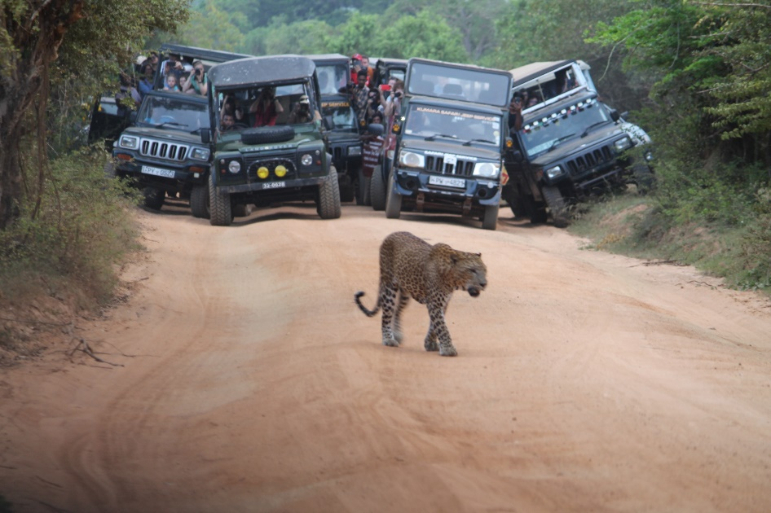
Figure 26. Over-crowding near a leopard, Yala National Park
(© IUCN, Sampath de A Goonatilake)

Layered on this over-visitation is the threat of irresponsible behaviour. Yala is famous for its easily visible leopards, and with mobile technology readily available, a leopard sighting is relayed to all jeep drivers, resulting in a rush — at high speeds — to get to the specified location, with the lamentable consequence that sometimes, animals — such as leopards and jungle cats — are run over (MoMd&E, 2016).

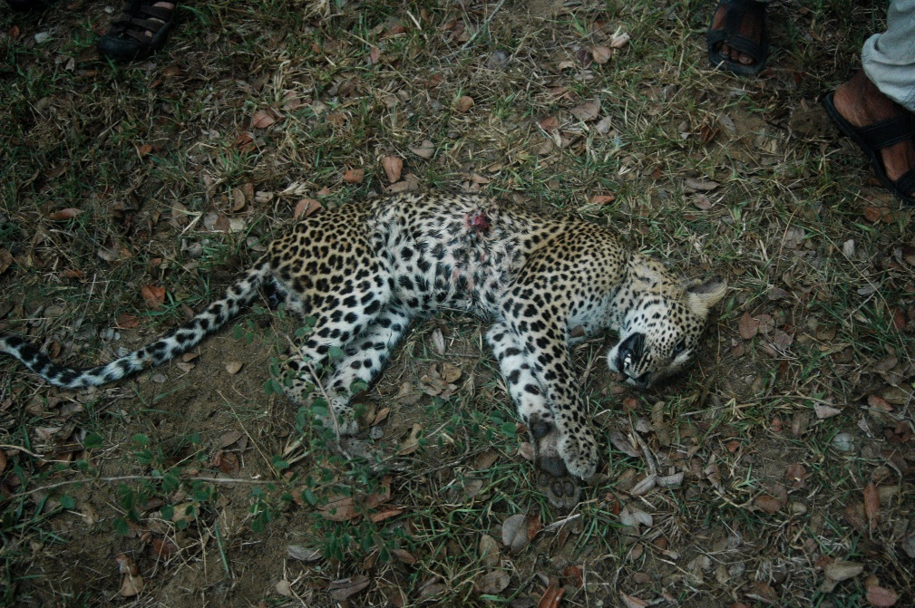
Figure 27. A leopard run over by a speeding jeep, Yala National Park
(© Spencer Manuelpillai)

Similar over-crowding is seen at the Gathering at Minneriya National Park, during the season.

Case Study 2: Irresponsible whale watching
Sri Lanka has emerged as a popular whale watching destination, where Kalpitiya in the north-west coast, Mirissa in the southern coast, and Trincomalee in the north-east coast allow for whale-watching year-round (Buultjens et al., 2016). The blue whale (Balaenoptera musculus), the sperm whale (Physeter macrocephalus) and several species of dolphins are commonly encountered in these locations Buultjens et al. (2016) report an increase in tourists from 620 in 2008 to 80,000 in 2014. As in the above case study, whale-watching in Sri Lanka suddenly received much publicising in the mass media (Wijeyeratne, 2014).

Whale-watching has become so popular that now there are tourists visiting purely to se whales ((Buultjens et al., 2016). Fishermen rapidly converted their fishing boats into tour boats and have as rapidly increased their incomes (Buultjens et al., 2016). Both the Coast Guard and the DWC have to provide licenses to these boats, but the number of boats going out to sea is unregulated (Buultjens et al., 2016). Once in the sea, the boat operators’ behaviour was also unregulated (Buultjens et al., 2016). As with leopards, when there is a sighting of a whale, boats rush as great speed to where the animal is, crowding the animal, and chasing after it after they submerge and surface again (Illangakoon, 2009).

Buultjens et al. (2016) report that although regulations were gazetted in 2012 to control this behaviour, its implementation and effectiveness will depend on the capacity and resources of the DWC.

They also report that the variability of the tour operations has resulted in ‘a highly uneven visitor experience . . .[t]he harassment of whales by the boats, overcrowding, a considerable time spent on rough seas with some boats spending up to six hours at sea, sea sickness and safety concerns on board the ships contributed to poor visitor experiences’ (Buultjens et al., 2016).

SLTDA (2016b) reports the following, under the section on lifting industry standards ‘Recent Tripadvisor reviews reveals a major problem in the management of whale-watching, particularly in the Mirissa area: small, slow, overloaded, smoky boats; significant proportions of guests becoming sea sick; chasing and harassing whales; operating tours out of season when the chances of seeing whales is slight and the sea conditions are rough. This type of feedback is building a negative reputation for Sri Lanka in this upscale niche market segment.’

Perhaps of much more concern is Illangakoon’s study of 2012, in the waters round Mirissa, which showed a clear spatial shift of blue whales (targeted for whale watching from Mirissa) which are moving from nearshore habitats further out, closer to a busy international, shipping lane also found in the area, increasing the risk of collision with ships.

Case study 3: Turtle hatcheries
Five of seven species of marine turtles — green turtles (Chelonia mydas), leatherbacks (Dermochelys coriacea), loggerheads (Caretta caretta), hawksbills (Eretmochelys imbricata) olive ridleys (Lepidochelys olivacea) nest on the southern and south-eastern coastlines of Sri Lanka (Rajakaruna et al., 2014). Until the mid-1990s, the major threats to these species were the collection of eggs for consumption and the killing of adults for their meat for food and the shells for ornaments (Rajakaruna et al., 2009). In 1993, the Fauna and Flora Protection Ordinance was amended increasing fines for the killing of marine turtles, and with it, the killing of adults decreased, but the collection of eggs continued (Rajakaruna et al., 2009). Although the first turtle hatchery was established as far back at 1956 by the Wildlife and Nature Protected society, it was not until the late 1970s that turtle hatcheries proliferated along the south-western coastline (Rajakaruna et al., 2014).

Figure 28. Number of turtle hatcheries in Sri Lanka
(Source: Rajakaruna et al., 2014)

A study of the current operational hatcheries by Rajakaruna et al. (2014) revealed that there were serious concerns about the management practices in these hatcheries: a) there is not knowledge about when and from where eggs are collected by the suppliers; b) The depth to which the eggs are buried is not determined in any of the hatcheries, although it is well-known that marine turtle exhibit temperature-dependent sex determination, In marine turtles, warmer nest temperatures tend to produce females, whereas cooler temperatures tend to produce males (Lasala et al., 2018); c) all hatcheries practised ‘headstarting’ and prevented free migration of hatchlings; c) often hatchling were reared in cages more crowded than recommended, and visitors were allowed to touch them; d) all hatcheries were unaware that it is illegal to operate a hatchery without a licence from the DWC. The study concluded that ‘the primary aim in maintaining a sea turtle hatchery in Sri Lanka was as a profit-oriented venture and may not provide positive conservation benefits. Poor practices were employed at most hatcheries. However, hatchery owners and/or managers were aware of the need for sea turtle conservation.’

Selection of sites for project activities

An attempt was made to short-list these locations as suggested by the Technical Advisory Committee member for Sustainable Tourism — based on distance from the nearest tourist hub on an established tourist circuit, inputs needed for establishing a sustainable tourism project in the location, scale of activity, availability of accommodation and road access. This short-listing did not provide a meaningful result as the scale of operations skewed the result. For example, in most locations suggested in the Trial Landscape 1, proposed tourism activities are establishing jeep safaris to observe elephants, which involves heavy financial and social inputs.

Recognising that community involvement can only be assessed through in-depth and repeated creation of awareness about what ecotourism is, which is beyond the purview of this phase of preparation of a project proposal, this parameter was omitted from assessments.

Box 2. Rural communities’ general perception of tourism

Much of the rural and less informed population of Sri Lanka understands tourism to be damaging to cultural norms (personal observation, IUCN, 2018), largely from reports from mass media. It is very likely that much of their [mis]understanding stems from well-publicised examples of Hikkaduwa, Tangalle, Mirissa and Medigama.

Hikkaduwa is a small coastal village in the south-west, whose traditional livelihoods were fishing, making coir ropes and cultivation (Ranasinghe, 2016). Tourism in Hikkaduwa was promoted in the late 1960s, and by the 1970s, budget, back-packer tourists began arriving in droves to the area, resulting in a proliferation of conversion of homes into boarding houses. Subsequently, serious, social issues of drugs and child prostitution were reported from the area, and tourist arrivals dropped drastically (Ranasinghe, 2016).

Conversely, in Tangalle (2012), Mirissa (2018) and Midigama (2018), in the southern coast, mass media reported serious sexual and physical assaults on tourists by local thugs (Fazlulhaq, 2012; Pinto-Jayawardene, 2018).

This is the view of tourism that the rural population of Sri Lanka has as a mind-set. Such mind-set and fears can only be changed and assuaged respectively, through rigorous, thorough and repeated creation of awareness about sustainable tourism, and in particular, eco-tourism, clarifying that communities will be involved in decision-making and providing a clear articulation of financial benefits for the community.

Because the short-listing did provide significant results, Figure 2 was examined closely with respect to a) distance from the nearest tourist hub on an established tourist circuit; b) distance to an emerging tourism hub, Mannar. Next, loops of new circuits were drawn around these hubs as shown in Figure 3.

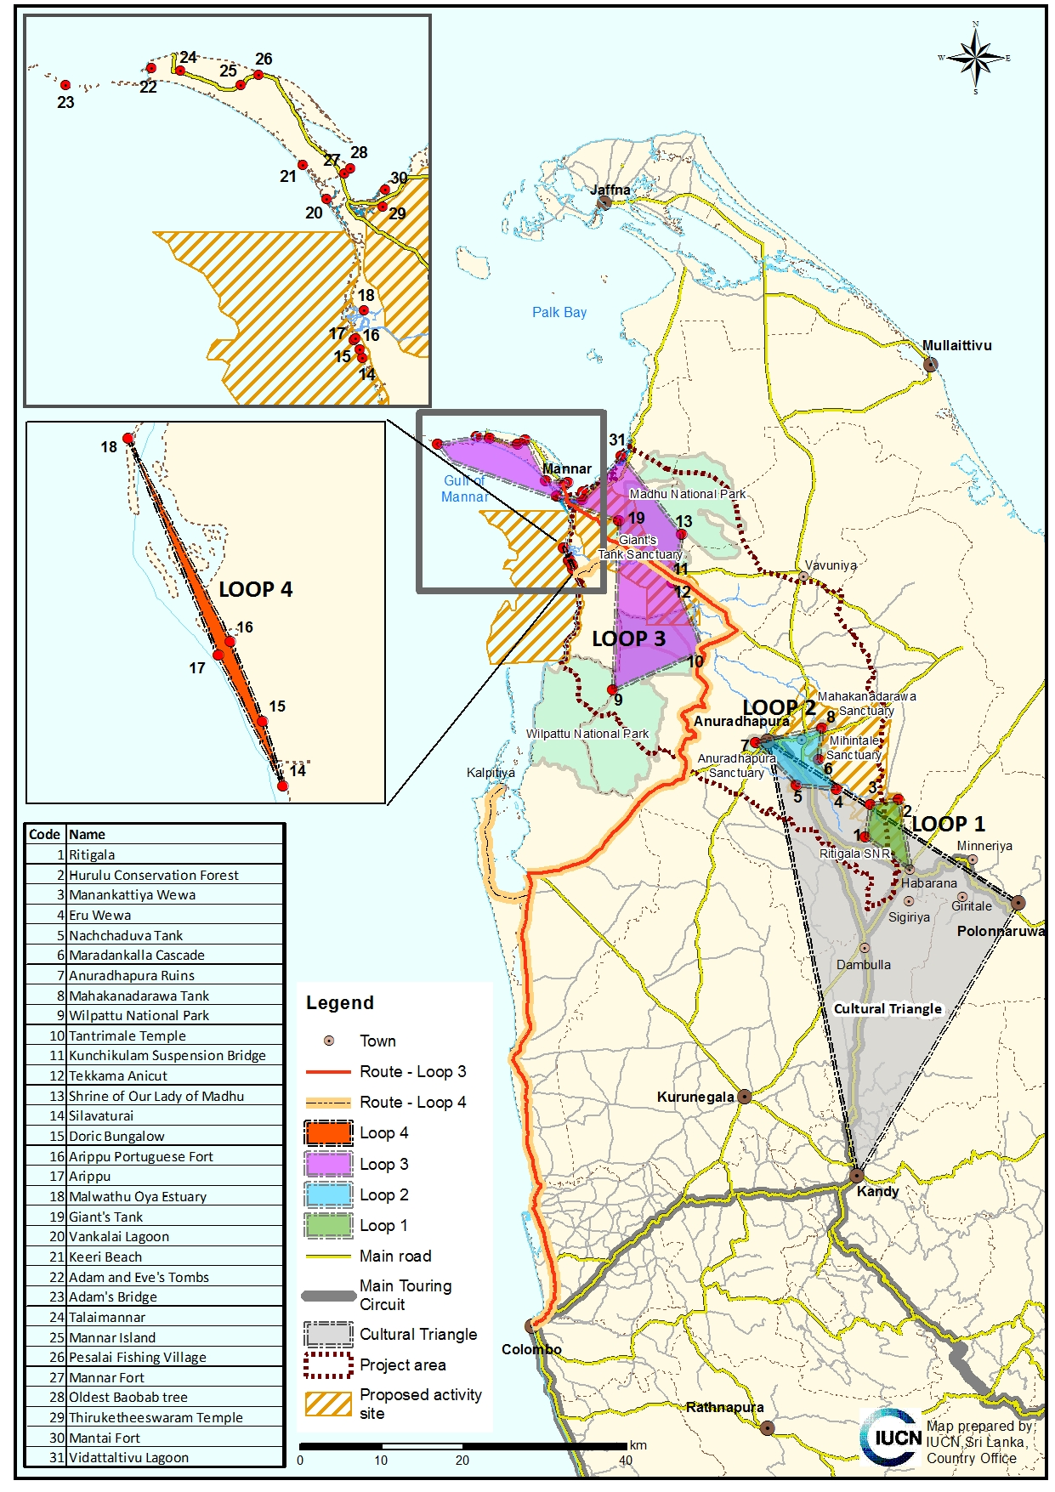
Figure 3: Proposed circuit loops for establishing sustainable tourism projects in the proposed project landscape

Proposed Loop 1 (the Habarana Loop)

The three locations in this loop are Ritigala, Hurulu Forest Reserve, and Manankattiya Sanctuary. All three locations are < 35 km (< 40 minutes) from Habarana, which is a popular tourism hub. Therefore, it will not be difficult to present these as new locations to tour operators set on a pre-determined circuit.

All three locations are protected areas.

Activities proposed in all three of the locations are elephant safaris. It should be noted that Habarana is a well-established hub for elephant safaris to Minneriya National Park, particularly between July and early September, when large numbers of elephants (~300) congregate around Minneriya Reservoir (dubbed the Gathering), one of the few locations in the dry zone that retains sufficient water for wild animals, yet providing lush vegetation for food in its draw-down area. There are concerns of over-visitation during the peak Gathering season, so establishment of elephant safaris in the three proposed locations will indubitably reduce pressure on Minneriya National Park.

Proposed Loop 2 (the Anuradhapura Loop)

The locations in this loop are Eru Wewa, Nachchaduwa Tank, Maradankalla Cascade, Anuradhapura ruins, Mahakanadarawa Sanctuary. Given that the Anuradhapura ruins are already a very popular tourism site, it is omitted from further discussion.

All locations are < 35 km (~ 45 minutes) from Anuradhapura, a major tourism hub in Sri Lanka. Therefore, it will not be difficult to present these as new locations to tour operators set on a pre-determined circuit.

Mahakandarawa is already a protected area under the jurisdiction of the DWC, while both Eru Wewa and Nachchaduwa have been proposed as sanctuaries under the Upper Elahera Canal Project under the aegis of the Mahaweli Development Authority (IUCN and MoMD&E, 2017).

Under this project, Eru Wewa is proposed for elephant safaris and for bird watching (water birds). Elephant safaris are also possible in Nachchaduwa and Mahakandarawa.

The Maradankalla Cascade is located next to existing tourist attractions — Mihintale and Kalu-diya Pokuna. The community and the relevant Development Officer from the Mihintale DSD are in support of a community-based tourism development project (IUCN, 2018). There is thus a possibility is there to establish agro-ecotourism project, with a model traditional village with homestay facilities (IUCN, 2018).

Proposed Loop 3 (the Mannar Loop)

The locations in this loop centre on the emerging tourism hub of Mannar Island and mainland. They are Wilpattu National Park, Tantrimale Temple, Kunchikulam Hanging Bridge, Tekkama Anicut, Shrine of Our Lady of Madhu, Giant’s Tank Sanctuary, Vankalai Sanctuary, nine attractions within Mannar Island (see Table 1), Mantai Fort and Vidattaltivu Nature Reserve.

The Shrine of Our Lady of Madhu is omitted from further discussion as it is already a very popular site for pilgrims from all over the island.

Mannar Island is approximately 113 km from Anuradhapura and not on an established tourism circuit (See Figure 2). However, it is an emerging tourism hub, for which 40 million LKR has been spent to improve infrastructure with the support from the World University Service (WUSC) for capacity building (Lanka Business Online, 2017). It is also emerging as a specialist avi-tourism site (de Silva Wijeyeratne, 2017; Jetwing Ecoholidays, pers. comm.; SLTDA, 2016b, Warakagoda et al.,2012). Thus, a new (emerging/ proposed in the SLTDA SAP) tourism circuit is proposed from Colombo as shown in Figure 3.

Giant’s Tank sanctuary and its surrounds (Wilpattu, Tantrimale, Kuchchikulam Hanging Bridge) are proposed as the focus of tourism activities in this project. However, accommodation is readily available in Mannar Island (22.6 km from, Giant’s Tank), and therefore, the other attractions on Mannar Island can be also be promoted although the island is outside the boundaries of the project area.

Proposed Loop 4 (the Arippu/Silavathurai Loop)

The locations in this loop are the Arippu and Silavaturai seascapes, Doric bungalow, Arippu Portuguese Fort, Malwathu Oya (Aruvi Aru) estuary. The Arippi and Silavathurai seascapes were identified in the first shortlisting process for a project location, as having potential for the establishment of a model marine and coastal habitat conservation programme, with the development of sustainable coral reef and mangrove-based ecotourism, with diving, kayaking, camping, snorkelling.

Silavathurai is 46.6 km from Mannar Town. Therefore, one option would be to link this proposed loop to Loop 3. Alternatively, it can be promoted as an additional leg to tourists visiting Kalpitiya for water-based activities, as the focus is the same (Figure 3).

Proposed actions within each loop

Loop 1 — the Habarana Loop

The proposed activity in this loop is establishing elephant safaris (Table 1). In order to achieve this, the following steps are necessary.

Creation of awareness and conservation education among communities in the area

Given that there is considerable distrust and antipathy towards the establishment of tourism and lack of knowledge about the vast difference between sustainable tourism and mass tourism, as well as the special characteristics of ecotourism, the project will need to conduct thorough, in-depth and repeated awareness programmes with communities in the region, to ensure a paradigm shift in their thinking about tourism.

This creation of awareness must explicitly state the financial benefits to communities and their participatory role in any proposed activity.

Creation of awareness and conservation education for government officers in the area

As above, for government and local government officials, to ensure that they, like hoteliers assessed by Bandara (2009) and by Arachchi et al. (2015), do not mistake ecotourism for nature-based or wildlife tourism.

Participatory discussions about proposed elephant safaris

Discussions and detailing proposals for proposed elephant safaris with communities and other stakeholders. Ensure that discussions include local government and divisional secretariat division officials, as well as relevant regulatory authorities (i.e., DWC, FD, CEA, SLTDA) and the private sector.

Checking the legal and policy framework

It is necessary to check whether there are any legal or policy impediments to commencing the proposed safaris — i.e., can the project be sited legally in the proposed location? Are proposed activities of the project legal? (Miththapala, 2011b).

Pre-requisites to implementation, once actions are finalised

For example, for Loop 1:

For elephant safaris

- Pre-assessing carrying capacities of the location for jeeps and number of visitors, before the selection of jeep drivers and tour guides;
- Selection and rigorous training of jeep drivers and tour guides, with concurrent development of explicit codes of conduct, and in conjunction with the DWC, established penalties for violations;
- Establishing clearly delineated routes for tours and establishing a mechanism with the DWC about monitoring adherence to the routes;
- Assessing DWC capacity for added duties and capacity building if needed;
- Making a concerted effort to promote these safaris to five tour operators. Linking these new locations with existing Habarana tours, as well as the emerging master plan for Trincomalee’s tourism (12Go Asia, 2018) should be possible.
- Conducting in depth conservation education and creation of awareness for the selected tour operators about ecotourism and how they can reduce their impacts on the environment.
- Establishing clear signage and a list of dos and don’ts for visitors.
- Ensuring a solid waste management and pollution reduction programme.
- Formulating best practice guidelines and ensuring implementation so that issues presented in Box 1 do not occur.
- Establishment of an overall, time-bound monitoring plan, with detailed responsibilities and organisations/persons responsible, to review and manage a) the permissible number of visitors and jeeps at a specified time; b) the maintenance and quality (in terms of comfort as well as emissions) of jeeps (often a complaint in Yala); c) adherence to codes of conduct and routes; d) adherence to prevention of pollution.
- Developing an investment plan for the above.

Loop 2— the Anuradhapura Loop

The proposed activities in this loop are the establishment of i) elephant safaris in Eru Wewa, Nachchaduwa and Mahakandarawa; and ii) establishment of an agro-tourism project, with a model traditional village with homestay facilities in the Maradankalla Cascade (Table 1).

For i) the process is as above, for the Habarana Loop.

For ii) the establishment of an an agro-tourism project, with a model traditional village with homestay facilities in the Maradankalla Cascade the following steps are necessary.

1 and 2 as above, for the Habarana Loop.

3. Participatory discussions and proposals of ecotourism projects
Discussions and detailing proposals for ecotourism projects with communities and other stakeholders.

4. Participatory selection of projects for implementation

The following is extracted directly from Miththapala (2011b). More details are provided in the same.
Selection should be based on objective criteria, such as
i) Considering whether community-based agro-tourism is an appropriate option
a) Considering the potential economic gains to communities: Essentially, an initial cost benefit analysis should be carried out for example, are the costs of a proposed project greater than the potential benefits for all stakeholders in a community? An often-encountered problem in community-based ecotourism is that it benefits only a few people in the community to make a difference. Otherwise, the financial gains go to an investor. If so, then the project should not be pursued.
b) Considering the potential conservation gain: Will the proposed project directly benefit conservation? Will the proposed project directly or indirectly engage communities in conservation? Will the proposed project divert communities away from damaging practices and allow for protection of a given area? Will the proposed project generate secondary problems for conservation – i.e. pollution, over-visitation
c) Considering the potential social gain: It is imperative that the community is involved from the very inception – consulted about whether a project is suitable for the area, and are involved in the development of the concept, design and other decision-making. Any plan or strategy that is developed must be not only ‘community-focused’ but also ‘community-led’ (WWF, 2001).
ii) Considering the preconditions for community-based ecotourism
- Suitability for conservation: This had already been addressed a priori.
- Suitability for tourism: This had already been addressed a priori.
- Suitable legal and policy framework: It is necessary to check whether there are any legal or policy impediments to commencing the conceived project. For example, can the project be sited legally in the proposed location? Are proposed activities of the project legal? Does the proposed project fit in with national/provincial/local tourism policies?
- Suitability for the community: Will the community benefit financially and socially? Will these benefits be equitable? Will these benefits target marginalised groups? Will the project have a pro-poor approach? Will the project have a gender focus? Is there capacity within the community to carry the project through? Can products be developed based on the community’s traditional knowledge, values and skills? If not, is there a willingness to undergo capacity building and focused training? Is the project likely to cause friction among groups within the community? If so, is there a way to guard against this?

5. Pre-requisites to implementation, once actions are finalised

Once the selection of projects is completed, the following steps are necessary.

For elephant safaris, as above, for the Habarana Loop, with promotion to another five tour operators.

For establishing an agro-tourism/model village project

- Ensuring and if needed, providing guidance for organic cultivation.
- Creating market linkages, outlets etc for produce and or products.
- Providing training in hygienic food preparation, preservation etc.
- A concerted effort of promoting these agro-tourism projects with five tour operators.
- In depth conservation education and creation of awareness for the selected tour operators about agro and ecotourism and how they can reduce their impacts on the environment.
- Formulating best practice guidelines and ensuring implementation so that issues presented in Box 1 do not occur.
- Developing an investment plan for the above.

Loop 3 — the Mannar Loop

The focus is this area should be two-pronged.

Giant’s Tank sanctuary and its surrounds (Wilpattu, Tantrimale, Kuchchikulam Hanging Bridge) are proposed as an area of focus of tourism activities in this project.

In order to achieve this, carry out 1, 2, 3 and 4 as above.

Once the selection of projects is completed, the following steps are necessary.

Giant’s Tank

- Restoring and re-positioning the existing disused DSD building as a DWC interpretation centre and staffing it.
- Establishing communication channels (through social media?) to alert avi-tourists to migrant arrival.
- Establishing clear signage and a list of dos and don’ts for visitors.
- Identifying local youths and providing rigorous training as tour guides to Giant’s Tank, Wilpattu, Tantrimale, Kuchchikulam Hanging Bridge;
- A concerted effort of promoting this new location (in combination with Mannar Island, see below) and new route (Figure 3) to five tour operators, largely as a avi-tourism location, but with other cultural sites included.
- In depth conservation education and creation of awareness for the selected tour operators about ecotourism and how they can reduce their impacts on the environment.
- Ensuring a solid waste management and pollution reduction programme for the area.
- Formulating best practice guidelines and ensuring implementation so that issues presented in Box 1 do not occur.
- Developing an investment plan for the above.

Mannar Island

It is here that visitors to Giant’s Tank and its environs will stay. There are 21 guest houses in Mannar Island (Table 3). During the reconnaissance visit by the team, the President of Mannar Guest House Owner’s Association noted that some these guest houses in Mannar (four-five) have capacities to host 20-30 people. However, these are neglected and not properly maintained as there is a lack of awareness about the attractions in the area (IUCN, 2018).

Thus, the second focus in the Mannar Loop should be to target these guest houses, uplift their service standards and ensure the integration of sustainable practices into the daily management.

The following steps will be necessary.
- Facilitating the registration of many of the guest houses in Mannar. Of the 21 guest houses listed in Table 3, which were identified from SLTDA (2018a) and advertised on the sites: Agoda.com, AirBnB.com, Booking.com. Only three are registered with the SLTDA. Registration provides free advertisement in the SLTDA’s accommodation guide exemption from tax levies, access to loans, grants, incentives and duty-free facilities (STLDA, 2018b).
- Providing rigorous and repeated capacity building to improve service standards, building on the WUSC programme. Currently, many of these establishments do not even maintain proper records. Private sector involvement from large hotel chains (such as Jetwing Hotels/Jetwing Eco-holidays, Aitken Spence Hotel, Cinnamon Hotels) will greatly benefit these establishments. These should include the following (see Table 4).
- Providing rigorous and repeated capacity building to integrate sustainable practices in daily management. Private sector involvement from large hotel chains mentioned above, will greatly benefit these establishments. These should include the following (see Table 4).

Table 4. Guiding principles of environmental management for the tourism sector
(Miththapala, 2011a, in ASSET, 2014)

Key performance areas | Guiding principles
Energy conservation (Reducing overexploitation) | Reduce energy consumption.
Energy conservation (Reducing overexploitation) | Replace fossil energy sources with renewable alternate energy
Energy conservation (Reducing overexploitation) | Replace old equipment with energy-efficient ones.
Energy conservation (Reducing overexploitation) | Maintain equipment for optimum use.
Water conservation  (Reducing overexploitation) | Reduce use.
Water conservation  (Reducing overexploitation) | Reduce waste
Waste water management  (Reducing overexploitation) | Treat wastewater and reuse.
Waste water management  (Reducing overexploitation) | Treat grey water and reuse.
Solid waste management (Reducing pollution) | Reduce purchasing and use.
Solid waste management (Reducing pollution) | Reuse materials as much as possible
Solid waste management (Reducing pollution) | Recycle as much as possible
Solid waste management (Reducing pollution) | Compost all garden waste.
Maintenance of air quality and reduction of emissions of greenhouse gases (Reducing pollution and reducing the impacts of climate change) | Minimise air pollution
 | Implement mitigation measures to deal with climate change
 | Implement adaptation measures to deal with climate change.
Prevention of chemical pollution (Reducing pollution) | Know details about the chemicals used and change to less harmful chemicals.
Prevention of chemical pollution (Reducing pollution) | Minimise use of pesticides
Prevention of chemical pollution (Reducing pollution) | Avoid use of chemical fertilisers, weedicides and fungicides
Using environment-friendly products (Reducing overexploitation, reducing pollution) | Minimise use of plastic.
 | Separate waste plastic and recycle
 | Switch to bio-degradable, environmentally-friendly products where possible.
Influencing the supply chain (Reducing pollution) | Examine and assess the supply chain.
Influencing the supply chain (Reducing pollution) | Influence suppliers to reduce unnecessary packaging.
Health and eco-consciousness (Reducing overexploitation) | Always provide healthy options with every meal.
Health and eco-consciousness (Reducing overexploitation) | Ensure that only legally permissible animal and plant products are served in the hotel.
Landscaping, erosion control, beach maintenance (Reducing habitat degradation) | Ensure natural erosion control methods are in place on beach fronts and hill slopes.
 | Use native plants for landscaping and avoid introducing plants from other countries.
 | Initiate organic gardening.
Corporate social responsibility | Ensure that local communities are not excluded in the planning and operation of a hotel.
Corporate social responsibility | Include environmental management in the hotel’s CSR portfolio.
Biodiversity conservation | Minimise damage to natural habitats.
Biodiversity conservation | Maximise species diversity.
Biodiversity conservation | Maximise species protection.

- Selecting and providing training for local tour guides, with a special focus of bird watching.
- Promoting these guest houses to the same tour operators targeted for Giant’s tank.
- In depth conservation education and creation of awareness for the selected tour operators about ecotourism and how they can reduce their impacts on the environment.
- Formulating best practice guidelines and ensuring implementation so that issues presented in Box 1 do not occur.
- Developing an investment plan for the above. Private sector involvement would greatly benefit these guest houses.

See also (as a separate PDF attachment) the guidelines provided to the government by Switch Asia – Greening Sri Lanka’s Hotels, which may be too technical for guest houses.

Loop 4 — the Arippu/ Silavathurai seascapes

Although this Loop provides access to beautiful coastal and marine ecosystems such as mangroves, sea grass meadows and coral reefs, and with them, opportunities for diving, kayaking, camping, snorkelling, it will be the hardest sell, as it is not near an existing tourism circuit.

Silavathurai is 46.6 km from Mannar Town. Therefore, one option would be to link this proposed loop to Loop 3. Alternatively, it can be promoted as an additional leg to tourists visiting Kalpitiya for water-based activities, as the focus is the same.

In order to achieve this, carry out 1, 2, 3 and 4 as above.

Once the selection of projects is completed, the following steps are necessary.

- In-depth discussions with another five tour operators (three who already operate in Kalpitiya and two who are already operating in Mannar) to identify the circuit that will be accepted by tour operators. This will be a critical step that will dictate the succeeding steps.
- Pre-assessment of carrying capacities of the locations (Malwathu Oya estuary, Arippu and Silavathurai seascapes) for the number of kayaks and number of visitors, before the selection of kayakers and tour guides;
- Selection and rigorous training of kayakers and tour guides, with concurrent development of explicit codes of conduct, and in conjunction with the DWC, established penalties for violations.
- Establishment of clear signage of dos and don’ts for divers and snorkellers
- Establishment of an interpretation centre with information about the importance of these ecosystems, the economic values, the threats facing them, threatened and protected species and a section of how tourists can help reduce threats to these ecosystems. Private sector involvement should be explored.
- Formulating best practice guidelines and ensuring implementation
- Developing an investment plan for the above. Private sector involvement would greatly benefit these guest houses.

Relevant literature

12GoAsia (2018). Trincomalee to Become Eastern Tourism Hub. https://12go.asia/en/post/6059/trincomalee-to-become-eastern-tourism-hub Retrieved Oct 2018.

Adventure Travel Trade Organization (undated). Adventure Travel Guide Qualifications & Performance Standard – III. Definitions Adventure Travel. https://www.adventuretravel.biz/education/adventure-edu/guide-standards/adventure-travel-guide-qualifications-performance-standard-iii-definitions/ Retrieved Jun 2018.

AgriTourism (2017). The concept. http://www.agritourism.in/the-concept/

Aitken Spence Hotel Managements (Private) Limited (2018). Green Initiative. https://www.aitkenspencehotels.com/green-initiative.html Retrieved Oct 2018.

Arachchi, R. S. S.,W, Ab. M. S. and Khatibi, Y. A (2015). Ecotourism Practices in Sri Lankan Eco Resorts: A Supplier Perspective Analysis. Journal of Tourism and Hospitality Management 3 (9-10) 169-180.

Advancing Specialized Skills for Economic Transformation (ASSET) (2014). An Environmental Strategy for the ASSET Programme. Consultancy report. Miththapala, S (2014). Unpublished report. 54 pp.

Bandara, Ranjit (2009). The Practice of Ecotourism in Sri Lanka: An Assessment of Operator Compliance towards International Ecotourism Guidelines. South Asia Economic Journal 10:2: 471–492.

Buckley, R. C. (2000). NEAT Trends: Current Issues in Nature, Eco and Adventure Tourism. International Journal of Tourism Research 2: 437-444.

Buultjens, J., Ratnayke, I., and Gnanapala, A (2016). Whale watching in Sri Lanka: Perceptions of sustainability. Tourism Management Perspectives 18: 125–133

Central Bank of Sri Lanka (2018). Economic and Social Statistics of Sri Lanka. Colombo: Central Bank of Sri Lanka, Statistics Department. 193 pp.

Cinnamon Hotels and Resorts (2018). Cinnamon CSR and Sustainability. http://www.cinnamonhotels.com/en/cinnamon-care.html Retrieved Oct 2018.

Department of Census and Statistics (2018). Employment. Pp 30-35 in Statistical Handbook 2018. Colombo: Department of Census and Statistics. 90 pp.
http://www.statistics.gov.lk/Pocket%20Book/chap03.pdf Retrieved Oct 2018.

Department of Census and Statistics (2018b). Poverty. Pp 15-29 in Statistical Handbook 2018. Colombo: Department of Census and Statistics. 90 pp.
http://www.statistics.gov.lk/Pocket%20Book/chap03.pdf Retrieved Oct 2018.

Department of Census and Statistics (2016). Sri Lanka Labour Force Survey Annual Report – 2016. Colombo: Department of Census and Statistics,Ministry of National Policies and Economic Affairs. 120 pp.
http://www.statistics.gov.lk/samplesurvey/LFS_Annual%20Report_2016.pdf Retrieved Oct 2018.

De Silva Wijeratne, G (2017). A photographic guide to the Birds of Sri Lanka. Colombo: Vijitha Yapa Publications. 296 pp.
Fazlulhaq, N (2012). Tangalle: Paradise lost. Sunday Times January 01, 2012.

Fernando, Sriyantha, Bandara, Jayatilleke S, and Smith, Christine (2016). Tourism in Sri Lanka. Pp 251-264 in M. C. Hall & S. J. Page (Eds.) The Routledge Handbook of Tourism in Asia. Abingdon, Oxon, UK: Routledge. 394 pp.

Fernando, S. M. D. and Kaluarachchi, K. A. S. P. (2016). Ecotourism Practices in Sri Lanka: The Case Study of Rainforest Eco Lodge. Colombo Business Journal 7(2):50-62.

Glaesser, D., Kester, J., Paulose, H., Alizadeh, A.,and Valentin, B. (2017). Global travel patterns: an overview. Journal of Travel Medicine 2017: 1–5.

Ilangakoon, A. (2012). Exploring anthropogenic activities that threaten endangered blue whales (Balaenoptera musculus) off Sri Lanka. Journal of Marine Animals and Their Ecology 5(1):1-7.

Ilangakoon, A. (2009). What are we doing to these gentle mammals of the sea? Sunday Times September 8, 2012. http://www.sundaytimes.lk/090222/Plus/sundaytimesplus_03.html. Retrieved Oct 2018.

International Irrigation Management Institute (1997). Gender and irrigation management transfer in Sri Lanka. Battaeramulla: IWMI. 27 pp. http://slwater.iwmi.org/sites/default/files/DocumentRoot/H021958.pdf Retrieved Feb 2018.

IUCN (2018). Managing together: Integrating community-centred, ecosystem-based approaches into forestry, agriculture and tourism sectors: Project Preparatory Grant (PPG): Designing of the full project proposal package. Trip Report: Reconnaissance visit to the project landscape along the Malwathu Oya watershed and adjacent environs during 15-17 July 2018. Unpublished report. 29 pp.

IUCN and MoMD&E (2017). The Wildlife Management Plan, including Human Elephant Conflict Management and Mitigation, for the Upper Elahera Canal Project (UECP) Colombo: IUCN and MMD&E. 392 pp, unpublished document.

Green Globe Travel (undated). How Mass Tourism is Destroying 30+ Destinations Travelers Love. https://greenglobaltravel.com/how-mass-tourism-is-destroying-destinations/ Retrieved Oct 2018.

Investopedia (2017). Rent-seeking. https://www.investopedia.com/terms/r/rentseeking.asp Retrieved Feb 2018.

Jaysuriya, Nalin. (personal communication). Managing Director, Aitken Spence Tours.
Ministry of Tourism Development and Christian Religious Affairs (MoTDCRA) (2017). Sri Lanka Tourism Strategic Plan 2017-2020. Colombo: MoTDCRA . 119 pp. http://www.sltda.gov.lk/sri-lanka-tourism-strategic-plan-2017 Retrieved Feb 2018.

Jetwing Hotels (2018). Sustainability at Jetwing Hotels. http://www.jetwinghotels.com/sustainability/ Retrieved Oct 2018.

Lanka Business Online (LBO) (2017). Mannar identified for major tourism development: Ministry. http://www.lankabusinessonline.com/mannar-identified-for-major-tourism-development-ministry/ Retrieved Oct 2018.

Lasala, J. A., Hughes, C. R. and Wyneken, J (2018). Breeding sex ratio and population size of loggerhead turtles from Southwestern Florida. PLoS ONE 13(1): e0191615. https://doi.org/
10.1371/journal.pone.0191615 Retrieved Oct, 2018.

Lenzen, Manfred, Sun, Ya-Yen , Faturay, Futu , Ting, Yuan-Peng , Geschke, Arne and Malik, Arunima (2018). The carbon footprint of global tourism. Nature Climate Change 8:522–528

Ministry of Mahaweli Development and Environment (MoMD&E) (2016). National Biodiversity Strategic Action Plan 2016-2022. Colombo, Sri Lanka: Biodiversity Secretariat, Ministry of Mahaweli Development and Environment. xxi + 284 pp.

Ministry of Tourism Development and Christian Religious Affairs (MoTDCRA) (2017). Sri Lanka Tourism Strategic Plan 2017-2020. Colombo: MoTDCRA. 119 pp. http://www.sltda.gov.lk/sri-lanka-tourism-strategic-plan-2017 Feb 2018.

Miththapala, Srilal (2014). Sustainable Tourism projects of the SWITCH-Asia Programme. Presentation made at the 2nd International Conference on Hospitality and Tourism Management. Galadari Hotel, Colombo 8th October 2014. https://www.switch-asia.eu/fileadmin/user_upload/Events/Colombo/SL_hotels_V3.pdf Retrieved Oct, 2018.

Miththapala, Sriyanie (2011a). Good practice guidelines on environmental management for Sri Lankan hoteliers. Colombo: SWITCH Asia Greening Sri Lanka Hotels Project, C C Solutions. xi + 120 pp.

Miththapala. S. (2011b). Guidelines for Community-based Nature Tourism in Sri Lanka. Colombo: IUCN and CARE. vii + 72 pp.

NewsFirst (2018). Yala Safari SUV Limits – Off limits
https://www.newsfirst.lk/2018/01/11/yala-safari-suv-limits-off-limits/ Retrieved Oct 2018.

Newsome, D., Moore, S. A. and Dowling, R. K. (2002). Natural Area Tourism: Ecology, Impacts and Management. Clevedon. Channel View.

Pinto-Jayawardene, Kishali (2018). Mirissa and Midigama attacks reflect Sri Lanka’s brutal realities http://www.sundaytimes.lk/180422/columns/mirissa-and-midigama-attacks-reflect-sri-lankas-brutal-realities-290608.html Retrieved Oct 2018.

Rajakaruna, R. S., Ekanayake, E. M. L., Kapurusinghe, T., and Ranawana, K.B (2014). Sea Turtle Hatcheries in Sri Lanka: Their Activities and Potential Contribution to Sea Turtle
Conservation. Indian Ocean Turtle Newsletter 20: 2-12.

Rajakaruna, R.S., Dissanayake, D.M.N.J. , Ekanayake, E.M.L. and Ranawana, K. B (2009). Sea turtle conservation in Sri Lanka: assessment of knowledge, attitude and prevalence of consumptive use of turtle products among coastal communities. Indian Ocean Turtle Newsletter 10: 1-13.

Ranasinghe, N (2016). Tourism development in Hikkaduwa as a setting for sexual and intimate relationships. Studies in Humanities and Cultures No. 26, Graduate School of Humanities and Social Sciences, Nagaoya University, Nagoya, Japan. 21 pp.

Seneviratna, A (1994). Ancient Anuradhapura. Colombo: Department of Archaeological Survey, GOSL. 346 pp.
Sirivardana, U. and Hettige, U. (2010). A million shorebirds at Vidattaltivu. Ceylon Bird Cub Notes. http://www.ceylonbirdclub.org/articles-2010-02.php Retrieved Jan 28, 2018.

Sri Lanka Tourism Development Authority (SLTDA) (2018a). Accommodation Guide May -October 2018. Colombo 10: Temple Publicity Services (Pvt) Ltd. For the SLTDA. 190 pp.

Sri Lanka Tourism Development Authority (SLTDA) (2018b). Benefits of registering with the SLTDA. http://www.sltda.lk/Benefits_of_registering_at_sltda Retrieved Oct 2018.
Sri Lanka Tourism Development Authority (SLTDA) (2017a). History. http://www.srilanka.travel/history Retrieved Jan 2018.

Sri Lanka Tourism Development Authority (SLTDA) (2017b). Monthly bulletin, SLTDA December 2017. http://www.sltda.lk/sites/default/files/Page1Dec17.pdf Retrieved Jan 2018.

Sri Lanka Tourism Development Authority (SLTDA) (2016a). Annual Statistical Report
of Sri Lanka Tourism — 2016. Colombo: Research & International Relations Division

Sri Lanka Tourism Development Authority. 74 pp.
http://www.sltda.lk/sites/default/files/annual-statical-report-2016.pdf Retrieved Jan 2018.

Sri Lanka Tourism Development Authority (SLTDA) (2016b). Sri Lanka Tourism Vision 2025. Colombo: SLTDA. 36 pp. Unpublished draft for discussion/

Sri Lanka UN-REDD Programme (2017). National REDD+ Investment Framework and Action Plan, 2017. Battaramulla, Sri Lanka: Sri Lanka UN-REDD Programme. xv+172 pp. [Online report] http://infosl.online/reddlk/web/index.php?option=com_content&view=article&id=157&Itemid=269&lang=en Retrieved August 15th 2017.

Sustainable Tourism (2014). Impact of tourism. https://sustainabletourism.net/ Retrieved Oct 2018.

Turtle Conservation Project - Sri Lanka (TCP) (undated). In-Situ Nest Protection Programme. http://www.sltcp.org/in-situ-nest-protection-programme-tcp-sri-lanka/ Retrieved Oct 2018.

UNESCO (2002). Biosphere Reserve Information Sri Lanka Hurulu. http://www.unesco.org/mabdb/br/brdir/directory/biores.asp?mode=all&code=SRL+01 Retrieved Oct 2018.

United Nations World Tourism Organisation (UNWTO) (2017). UNWTO Tourism Highlights 2017 Edition. Place unknown: UNWTO publications. 16 pp. https://www.e-unwto.org/doi/pdf/10.18111/9789284419029 Retrieved Jan 2018.

United Nations World Tourism Organisation (UNWTO) (2013). Sustainable Tourism for Development Guidebook. Spain: UNWTO. Pp 208. https://greenglobaltravel.com/how-mass-tourism-is-destroying-destinations/ Retrieved Oct 2018.

United Nations World Tourism Organisation (UNWTO) (2012). Ecotourism and protected areas. http://sdt.unwto.org/content/ecotourism-and-protected-areas Retrieved Oct 2018.

United Nations World Tourism Organisation (UNWTO) (2005). Definition of sustainable tourism. http://sdt.unwto.org/content/about-us-5 Retrieved May 2018.

Warakagoda, D., Inskipp, C., Inskipp, and Grimmett, R (2012). Birds of Sri Lanka. London: Christopher Helm. 234 pp.

Weerakoon, D., Goonatilake, S. De A., Wijewickrama, T., Rajasuriya, A., Perera, N, Kumara, T. P., De Silva, G., and S. Miththapala. (2018). Conservation and sustainable use of biodiversity in the islands and lagoons of northern Sri Lanka. Colombo: International Union for Conservation of Nature, Colombo, Sri Lanka and Government of Sri Lanka. xxix + 287 pp.

Wickramasinghe, K (2107). Measuring Sri Lanka’s sustainable tourism: Missing piece of the puzzle. Mirror Business, Daily Mirror, Sri Lanka, Oct 4th 2017.

World Travel and Tourism Council (WTTC) (2018). Travel & Tourism Economic Impact 2018
Sri Lanka. London, UK: WTTC. 24 pp.

Wijeyeratne, G de S (2014). Wild Sri Lanka (Wild Places of Asia). London: John Beaufoy Publishing. 208 pp.

Rearing hatchlings in captivity
The Turtle Conservation Project (TCP) is not reviewed in the above, likely as the project leader is one of the authors of Rajakaruna et al., 2014. However, it should be noted that the TCP practices in-situ nest conservation involving a ‘comprehensive community conservation programme’ (TCP, undated).
This training should include information a) about ecotourism and how it is different from mainstream tourism and its guiding principles of i) Do no harm; ii) take from the earth only what the minimum essentials; and iii) put back to the earth only minimum waste (Miththapala, 2011a); b) conduct and behaviour in the field; c) the biology and behaviour of elephants, the threats to their survival and their conservation.
The Federation of Environmental Organisations, in collaboration with the DWC and SLTDA provide a full day course (in two half days) to jeep drivers introducing concepts of discipline within a park and providing knowledge to give their clients a better service. So far 220 and 45 jeep drivers in Minneriya and Wilpattu respectively, have followed this course, which began in July 2018 (Rohan Wijesinghe, person. comm)
‘Agro-tourism is a commercial enterprise at a working farm, or agricultural plant conducted for the enjoyment of visitors that generates supplemental income for the owner’ (AgriTourism, 2017)
It is the author’s opinion that although Wilpattu has been added as a sustainable tourism location by the field team, it should be omitted from the Mannar Loop for easier access to locations.

